OFFICE OF THE CHIEF FINANCIAL OFFICER

Financial Management Information System (FMIS)

Version 6.3 User Guide



Last Updated: April 2011

U.S. General Services Administration
Office of the Chief Financial Officer
Washington, D.C.

Table of Contents

I. About this User Guide 4
II. Application Background 5
III. Access and Log-In 6
IV. Data Collection Process 11
a. Valid Accounting Transactions (VAT) Data Collection 11
b. Non-VAT Data Collection 11
V. Query Grids and Non-Query Grids 13
a. Query Grids 15
b. Non-Query Grids 16
c. Identifying Appropriate Queries 17
VI. Most Frequently Used Queries 19
a. List of VAT Numbers 19
b. Pegasys VAT Query Grid 20
c. VAT Search 22
d. Transactions by Document Number(s) 24
e. Income and Expense 25
f. Obligations 27
g. Pegasys Open Item Summary and Detail 29
h. Pegasys Trial Balance Detail and Summary 31
i. Work Authorization 33
j. RPADS and RPADS Capital Report 35
k. Database 36
l. Search by ACT Numbers 37
VII. Query Results 38
a. Sorting Data 38
b. Filtering Data 40
VII. Saving Data 41
VIII. Printing Data 42
VIV. Trouble-Shooting Printing and Saving Issues 43
Appendix I: System Menu Functions 45
Appendix II: Historical Modifications to Valid Accounting Transactions 48
Appendix III: List of Key Data Codes and Descriptions 49
Appendix IV: Pegasys Document Types 52

I. About this User Guide

After reading this Guide, User of the Financial Management Information System (FMIS) should have the ability to successfully meet the below-mentioned performance objectives.
Table 1: Key Learning Areas
Key Learning Areas | Objective Definition
Application Access and Log-In | - Understand how to successfully log-in to FMIS  - Understand the most frequently needed trouble-shooting tips for accessing the application
Valid Accounting Transaction (VAT) Data Collection Process | - Understand how VAT data is collected and when refreshed data will be available  - Understand how long VAT data remains in the FMIS system
Queries | - Understand the differences between Query Grids and Non-Query Grids  - Understand when and how to use Indexes  - Understand when and how to use Wild Cards
Most Frequently Used Queries | - To understand how and when to use the most frequently-utilized queries in FMIS
Saving and Printing Data | - Understand how to save query results to their local hard drive or to the network for retrieval and use later  - Understand how to successfully print query results to mapped printers  - Understand how to trouble-shoot the most common printing and saving issues

Additionally, throughout the User Guide there are varous Quick Tips that provide instructional and background information on important concepts and trouble-shooting.

It is recommended that this User Guide be used in conjunction with the FMIS Quick Reference Cards, which are also available virtually for Users requiring a consolidated version of key application information.

II. Application Background

The Financial Management Information System (FMIS) serves a vast number of Federal accounting and financial professionals that require up-to-date accounting information on a consistent basis. Originally created to make data from the National Electronic and Accounting Reporting Application (NEAR) accessible via a modern query tool, FMIS now holds data primarily from Pegasys.

An important feature of FMIS is that it provides the User with access to financial information processed in Pegasys daily and the ability to run queries and reports to support management decisions. There are many types of financial data available in FMIS some of which are commitments, income, obligations, expenses, and vendor payments for example.

The financial data that comprises FMIS arrives from multiple sources, as referenced in the below graphic:

Figure 1: FMIS Inputs and Outputs
The application employs robust data level scripting in order to provide the User with the with financial data in an easy to understand format for all consumers of financial information.

Consumers of financial information that regularly access FMIS for the generation of reports can be segmented into six distinct groups, as indicated in the below graphic:

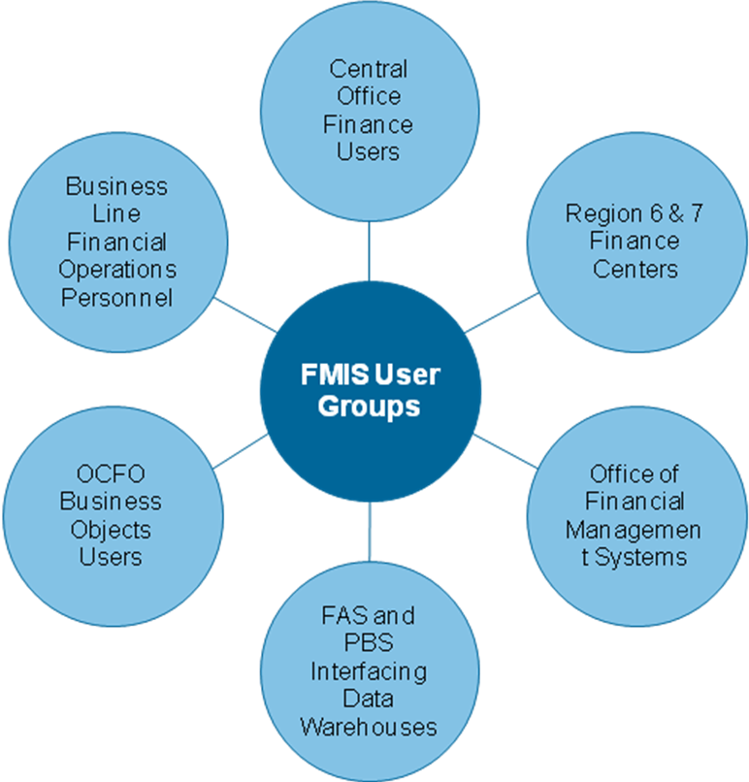
Figure 2: FMIS Users
It is important to note that while individuals from the above-mentioned groups may comprise the largest segment of Users, FMIS is a diversely-used application that spans multiple organizations both internal and external to GSA.

III. Access and Log-In

SECTION LEARNING OBJECTIVES
- Understand how to successfully log-in to FMIS
- Understand the most frequently needed trouble-shooting tips for accessing the application

WHEN TO REVIEW THIS SECTION
- Upon learning to log-in to the application
- Upon experiencing problems during the log-in phase

FMIS Log-In Instructions

Please Note: GSA employees that are teleworking should first establish a connection through the VPN before proceeding with Step 1. Users should not use the GSA Apps Citrix to connect to FMIS.

- Access the FMIS Homepage. GSA employees should visit http://cfo.fmis.gsa.gov/
OCFO External Customers should visit https://xpwi.gsa.gov

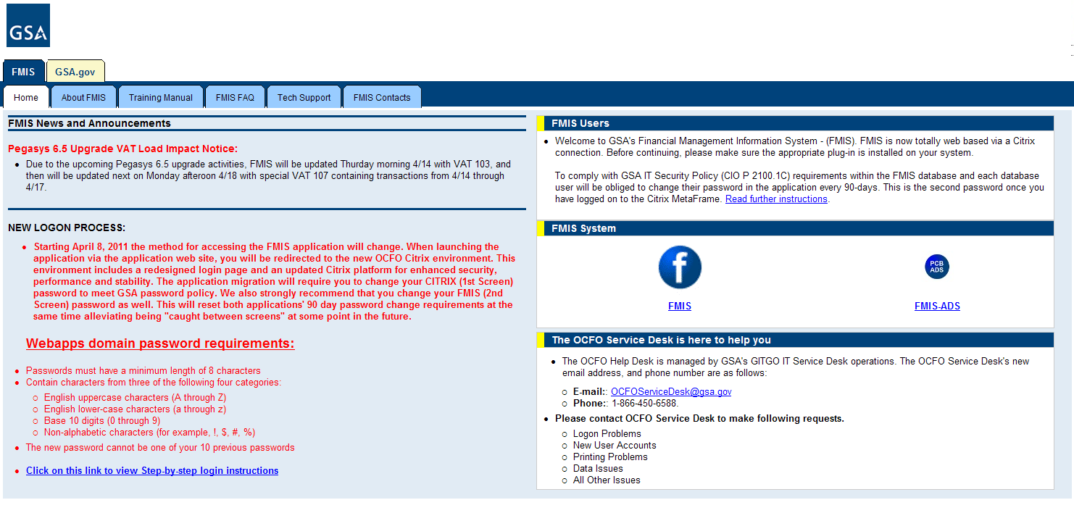
Figure 3: FMIS Home Page
- Click on the left icon to launch FMIS. This will launch the Web Interface of the CFO Citrix.

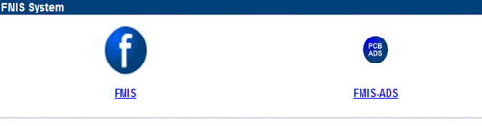
Figure 4: FMIS Icon
- Log into the Web Interface with your existing domain credentials.
  - For first-time Users, the application will request the User to change the domain password.

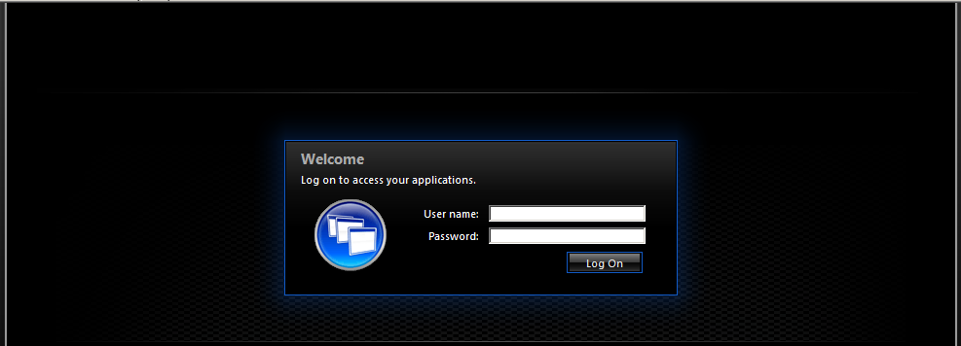
Figure 5: Citrix Log-in Screen

- Click on the FMIS icon to launch the application.

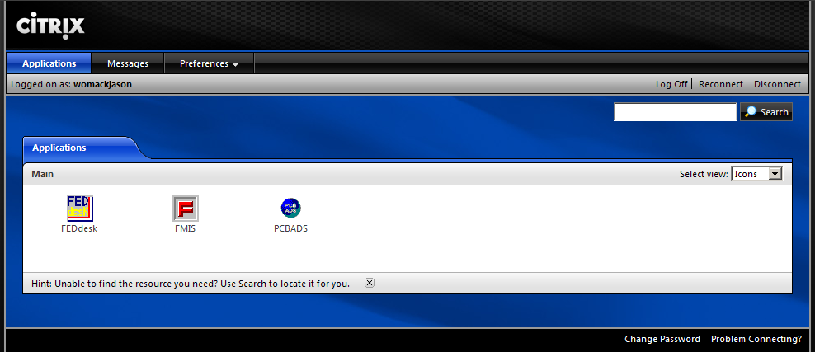
Figure 6: Citrix Applicaton Menu
- Click “OK” to accept the access agreement.

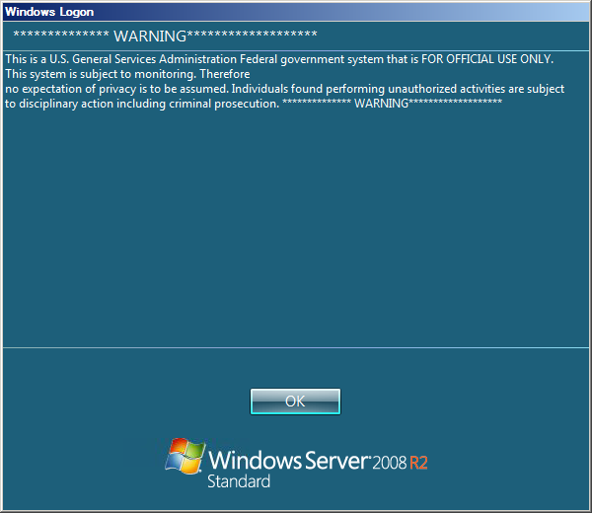
Figure 7: Citrix Acceptance Screen

- Log into the FMIS application.

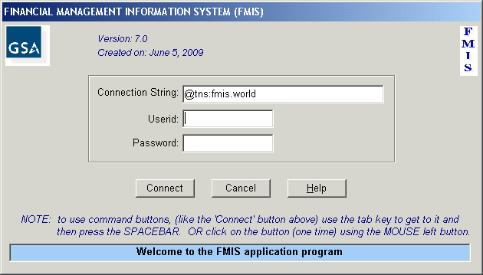
Figure 8: FMIS Log-in Screen
- Click “OK” on the next screen to acknowledge recognition of the most recent VAT update.

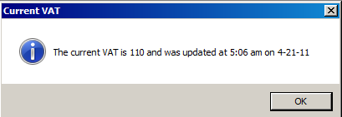
Figure 9: Current VAT Notification Screen

- Once logged-in to Citriz and FMIS, the User should choose to allow the server to access their hard drive and system resources so that printers and drives are accessible within the system.

In order to grant full access rights from within the application, the User should perform the following steps:

- Double-click on the Citrix Program Neighborhood Connection Status icon on the lower right corner of the screen

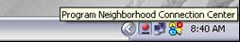
Figure 10: CitrixProgram Neighborhood Connection Status Icon
- Within the Program Neighborhood Connection Center, highlight the FMIS connection and then click the “File Security” button.

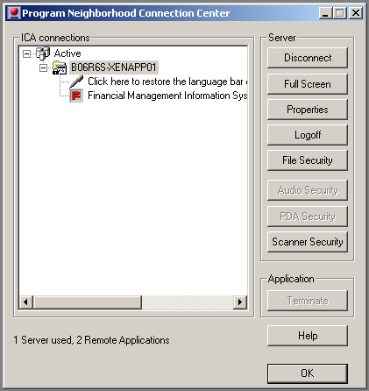
Figure 11: ICA Connections Window (Citrix Version 10.2)

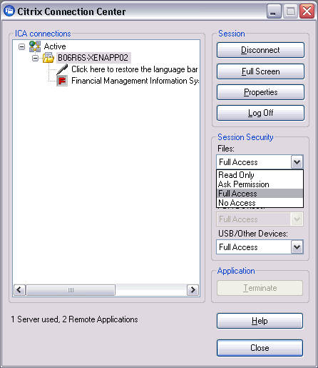
Figure 12: ICA Connections Window (Citrix Version 12.1)

- Within the Client File Security window, select “Full Access” and click “OK”.

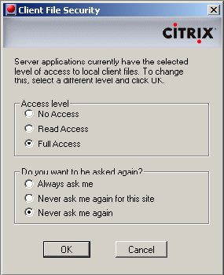
Figure 13: Client File Securty Window

Instructions to Change FMIS Password

- Click ‘File’ in the main FMIS menu.
- Select ‘Change Password’.
- Update your password as prompted and click ‘OK’.

Figure 14: Password Update Screen

QUICK TIP #1: PASSWORD CREATION
While FMIS Users have only one User ID, it is possible to create two distinct passwords for the Citrix and database log-ins. For both log-ins, FMIS users are required to change their passwords every 90 days.

The FMIS password must be at least 8 characters in length and include letters, numbers and a special character.

Passwords are case sensitive, usernames are not.

Acceptable special characters are:` ~ ! @ # $ % ^ & * ( ) _ + - = { } | [ ] \ : " ; ' < > ? , . /

If changing your password within Citrix, you will receive an automatic confirmation at the time of modification.

It is important to note the following about the Citrix log-in process:
- The Citrix client will prompt users to update their password starting at 14 days before the 90-day date is approaching
- After you update your Citrix password, you should then change your password in FMIS under the ‘File’ menu (Important Note: FMIS will not allow you to change your password after the 90-day mark has passed, so you must be diligent about updating it prior to that time)

QUICK TIP #2: REQUESTING A PASSWORD RESET
The Users should contact the OCFO Service Desk to request that his or her password be reset in the following circumstances:
- After multiple unsuccessful log-in attempts, the User will receive a notification of account lock-out
- If after logging into the second screen, the User receives the following error message: “ORA-06401: Invalid Driver Designator”
- The User’s password contains invalid characters and must be reset. In addition to contacting the OCFO Service Desk, the User should review the password character requirements located at http://cfo.fmis.gsa.gov/faq.htm
- The User receives error message “ORA-28000: Message 28000 not found; product=FDBMS73; facility=ORA Please try again”

QUICK TIP #3: LOCK OUTS
- If the User receives an “Exceeded Sessions per User Limit” error message after logging into the second screen, the User should wait one hour to log in again. This will allow enough time for the two previous sessions on the database server to time out.

QUICK TIP #4: LOSS OF CONNECTION
- If a User loses connectivity to Oracle after having logged-in to FMIS, the error message shown below will appear
- In this case, the User should exit FMIS and log-in to the system again to reconnect to Oracle

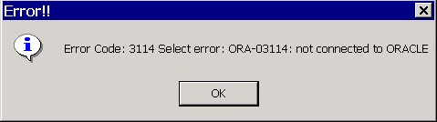
Figure 15: Loss of Connection Error Code

IV. Data Collection Processes

SECTION LEARNING OBJECIVES
- Understand how VAT and non-VAT data is collected and when refreshed data will be available
- Understand how long VAT and non-VAT data remains in the FMIS system

a. Valid Accounting Transactions (VAT) Data Collection

VAT Data for FMIS is extracted daily from the Pegasys accounting journal, transaction journal, general ledger journal and fixed assets journal.

The cut off times for the transactions start from midnight of the day before thru midnight of today. The exact daily cut off time for the loading of data is 0500 GMT.) Weekend transactions are merged into Sunday’s VAT date and loaded on Monday mornings.

The FMIS application allows users to query the past 5 years worth of VATs However, we store all VATs back to FY 1995 and is available upon approved special request to the Office of Financial Management Systems.

Each VAT is identifiable by a specific VAT number, which corresponds to the three-position Julian date from which the transaction originated. All weekend data is combined into Sunday’s date. For example, a transaction that contains VAT number 108 in FY 2011 corresponds to data from April 18th, 2011. VAT number 114 in FY 2011 corresponds to data from the weekend of April 23-24th, 2011.

For a visual display, the below graphic depicts the process for the refreshing of FMIS data from its original sources:

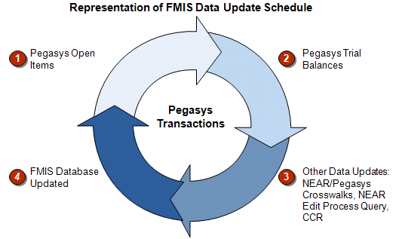
Figure 16: FMIS Update Schedule

A useful product of the VAT data loaded in FMIS are the Category Lists which are pre-filtered queries by the major Standard General Ledger functional categories. They also normalize the amounts on the VAT transactions allowing you to sum them together to more easily obtain a balance for a particular general ledger account.The definitions for each VAT Category List are as follows:
Table 2: General Ledger Category List and Codes
VAT Category List | Corresponding Standard General Ledger Codes
Assets | * 14XX, 15XX, 16XX, 17XX, 18XX, 19XX
Income | * 5XXX and 71XX, excluding 5610
Expense | * 6XXX, 72XX
Obligations | 4801, 4802, 4899, 4901, 4902, 4881, 4882, 4981, 4982
Delivered Orders | 4901, 4902
Prior-year Recoveries | 4871, 4872, 4971, 4972
Deferred Income | 2320.01, 2310.04, 2310.01
Unfilled Customer Orders | 4221, 4222

* XX indicates a Wild Card

The following two categories of reports are also derived from the VATs:
Table 3: Obligations and Income/Expense Reports Descriptions
Obligations Reports Menu | Income/Expense Reports Menus
Various pre-formatted reports that summarize by different levels of accounting dimensions | Various pre-formatted reports that summarize by different levels of accounting dimensions
Pre-filtered on certain 4XXX standard general ledgers Income/Expense | Pre-filtered on certain 5XXX and 6XXX standard general ledgers

b. Non-VAT Data Collection

Table 4: Miscellaneous Category Type Definitions
Miscellaneous Category
Type Definitions
Pegasys Open Items
Daily cycle updated open obligations balances

Pegasys Trial Balances
Detailed trial balance from General Ledger summary tables

NEAR/Pegasys Crosswalks
Tables that crosswalk the coding previously used in the NEAR application to the coding currently used in Pegasys

NEAR Edit Process Query
This query provides the data that has rejected from NEAR, before it gets to Pegasys, that must be corrected in order to be allowed to feed into Pegasys

V. Query Grids and Non-Query Grids

SECTION LEARNING OBJECTIVES
- Understand the differences between Query Grids and Non-Query Grids
- Understand when and how to use Indexes
- Understand when and how to use Wild Cards

The Financial Management Information System application (FMIS) contains two basic types of queries: Query Grids and Non-Query Grids. Query Grids resemble spreadsheets (rows and columns of data in cells) in which searches can be performed for any value of any data element defined in the columns shown . Non-Query Grids prompt the User to input selection criteria into labeled text box fields in order to return data in various report formats.

Certain fields in the FMIS database have been indexed to improve query response times. For maximum performance, users should provide a value under a starred column of the Query Grid (for example, Fund Code 192X) Non-Query Grids have been programmed to utilize indexes as well.

The below instructions allow a User to review a particular index.

Instructions to Use the Referencing Index

- Select Database from main menu
- Select Indexes
- Review the Table Name and Index Name of preference

FMIS also supports the use of Wild Cards to allow the User to search for data that matches certain patterns or contains certain characters. Keep in mind that the query will generate its results more slowly when a User uses more than one Wild Card because of the increased number of comparisions that must take place in the database.

Two Wild Card formats are supported by the FMIS application. Wild Cards allow the User to search for data that matches certain patterns or contains certain characters.

The two primary Wild Card operators are the percent sign and underscore:
Table 5: Wild Cards
Wild Cards
%  (percent sign) | Replaces any number of characters or any value.  For example, in organization code field, S00B% will represent any organization code that starts with S00B, the Office of the Chief  Financial Officer in Central Office.
_  (underscore) | Replaces one character of any value.  For example, in object class field, 2_ will represent any object class that starts with 2 (as in 21, 22, 23, 25 or 26).

QUICK TIP #5: OPERATORS
Operators utilized in FMIS Query Grids include the following:
- LIKE
- NOT LIKE
- LESS THAN (use <)
- GREATER THAN (use >)
- AND
- OR
- IN

Query Grids

WHEN TO REVIEW THIS SECTION
- To develop a query grid
- To use wild cards in query grids
- To employ boolean operators

A Query Grid is comprised of columns and rows where the User can enter search criteria.

Instructions to Use the Query Grid

- Enter search criteria on separate rows under appropriate columns for each accounting dimension
- To include criteria on the same line, use AND
- To include criteria on the next line, use OR
- Once all the desired criteria have been entered, select “Retrieve” for to generate the results
- When viewing the results, double-click on the actual accounting element within the returned data to amplify the description of a particular accounting element (i.e. Organization Code, Fund, BA, Object Class, Cost Element, Building, Debit or Credit)

Quick Tip #6: Query MENU TOOLBAR
Below is an example of the toolbar that Users will notice in the upper lefthand of the Query menu bar:

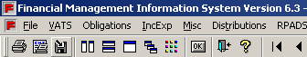
Figure 17: FMIS Toolbar
Place the cursor over the different toolbar images to display their function.

Quick Tip #7: Using Wild Cards in Query Grids
Instructions to Use Wild Cards in Query Grids

- Select the Query Grid of preference
- Place the cursor in the second row of the desired data criteria column
- Insert the operator LIKE
- Insert search criteria (i.e. FY20)
- Insert Wild Card of preference (percent sign or underscore)

For example
LIKE FY20%

Quick Tip #8: Adding a Second Line to a Query Grid
To illustrate the different combinations of queries that the User can enter into a FMIS Query Grid, consider the following example:

A FMIS user wants to search for the same kind of transactions that have 48% in both General Ledger Debit and Credit. How can this be accomplished?

The user must perform the following steps:

- Choose the correct Fiscal Year (in this example, the FY is 2011)
- Enter the Fund Code (in this example, the code is 142)
- Enter the Budget Activity (in this example, the code is GA10)
- Enter the Function Code (in this example, the code is GAH40)
- Enter the Object Class Code (in this example, the code is 25)
- Add a second line to repeat the same data, distributing separately Debit and Credit on two lines
- Select “Retrieve”

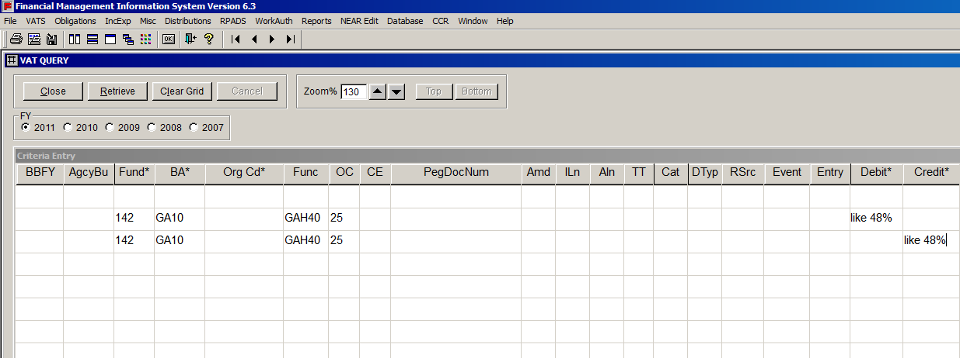
Figure 18: Pegasys VAT Query Grid Screen

Non-Query Grids

When to Review this Section
- To use a non-query grid
- To understand vat category lists

Perhaps the most significant Non-Query Grid is the VAT Category Lists. The Users can select transactions without knowing the general ledgers and simply must enter a few criteria and pick a category: Income, Expense, Obligation, Undelivered Order or PY Recovery.

Instructions to Use the VAT Category Lists

- Select VAT Category List from the VAT menu
- Enter the Book Month (defaulted value is the current month) or indicate a period of interest in the VAT range
- To search the whole fiscal year, the User will need to enter the first VAT of the fiscal year then the last VAT of the fiscal year or leave the fields in this section blank

Figure 19: VAT Category List Range

Instructions to Use the List of VAT Numbers

- Select VATs
- Select List of VAT Numbers from the main menu
- Indicate the Fiscal Year of interest
- The system will automatically display the results

Quick Tip #9: Using Wild Cards in Non-Query Grids
Please note that when using Wild Cards in Non-Query Grids, the operator LIKE is NOT required.

Instructions to Use Wild Cards in Non-Query Grids

- Select the Non-Query Grid of preference
- Insert relevant required information in the search fields
(e.g. Fiscal Year, Book Month, BBFY, Fund, Region, Budget Activity, and Object Class)
3) Use Wild Card (e.g. percent sign, underscore) immediately after field criteria (e.g. Fund: 151%)

Identifying Appropriate Queries

When to Review this Section
- How to know which query is most appropriate to use to generate based on the user’s needs

Table 6: Data Needs and Relevant Queries
Customer Query Needs | Location | Corresponding Queries
Identify or review Income  Transactions | VATS Menu  IncExp Menu | VAT Income Category List Button  Income Queries
Identify or review Expense Transactions | VATS Menu  IncExp Menu | VAT Expense Category List Button  Expense Queries
Identify or review Obligations | VATS Menu  Obligations Menu | VAT Obligations Category List Button  Obligations Queries
Identify or review Delivered Orders | VATS Menu  Obligations Menu  Query Grid  (Specify: Delivered Orders General Ledgers) | VAT Delivered Orders Category List Button  Obligations Query Grid
Identify or review Prior Year Recoveries | VATS Menu  Obligations Menu  Query Grid  (Specify: PY Recoveries Gen. Ledgers) | VAT Prior Year Recoveries Category List Button  Obligations Query Grid
Identify or review Cash Entries | VATS Menu  VAT Query Grid (Specify: Cash General Ledgers) | VAT Cash Category List Button  VAT Query Grid
Identify or review Commitments Entries | VATS Menu  VAT Query Grid (Specify: Commitments General Ledgers) | VAT Commitments Category List Button  VAT Query Grid
Identify or review Pegasys Open Items | Miscellaneous Menu | Pegasys Open Items Summary Query  Pegasys Open Items Detail Query
Identify or review Pegasys Trial Balance | Miscellaneous Menu | Pegasys Trial Balance Summary Query Grid  Pegasys Trial Balance Detail Query Grid  Pegasys Trial Balance Summary by Standard General Ledger
Identify or review Work Authorizations | Work Auth Menu | Work Authorization Summary Query  Work Authorization Details Query
Review a Pegasys Document | VATS Menu | Transactions by Document Number Query
Identify or review Real Property | RPADS Menu | RPADS Query
Look up a clear text description of an Accounting Code | Database Menu | Choose corresponding query under Database Menu
Look up ACT Number | VATS Menu | ACT Number Query
Look up Vendor Payments | Miscellaneous Menu | Pegasys Vendor Payment Search

VI. Most Frequently Used Queries

SECTION LEARNING OBJECTIVE
- To understand how and when to use the most frequently-utilized queries in FMIS

List of VAT Numbers

When to Review this Section
- To view all vats being processed in each fiscal year
- To display the load date as well as the records count

Instructions to Use List of VAT Numbers

  - At the main FMIS menu, select VATS
  - Select “List of VAT Numbers”
  - On the left side of the screen, select fiscal year of interest
  - Based on the User’s preference for viewing the data, select how to sort the data
  - The User may now print, save or exit the data results as needed

Below is an example of the results of an actual List of VAT Numbers Report:
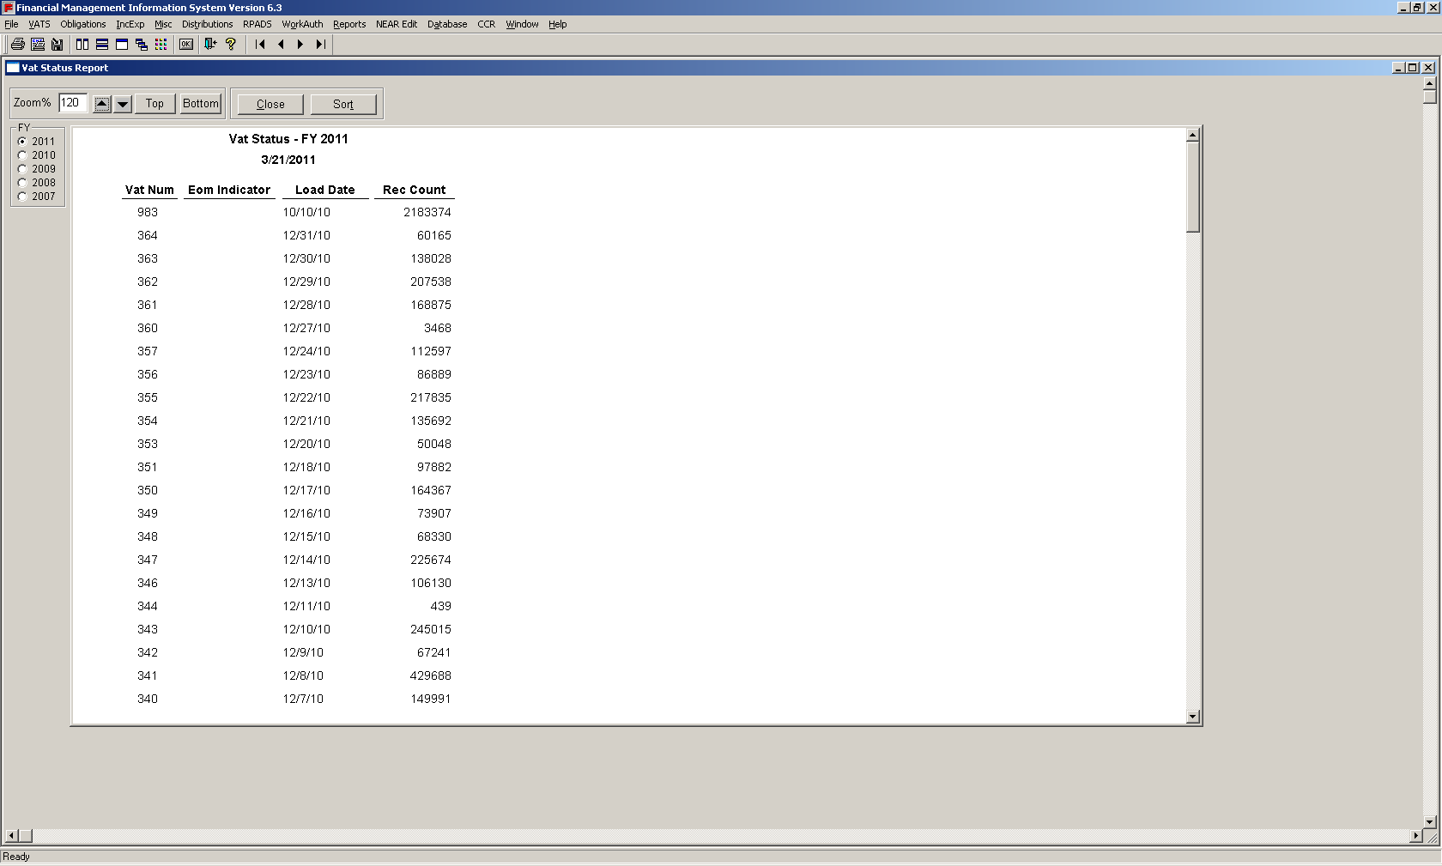
Figure 20: List of VAT Numbers Report

Pegasys VAT Query Grid

When to Review this Section
- To verify posting of transactions and determine account balance
- To generate information on all transactions that took place during a fiscal year

Instructions to Use the Pegasys VAT Query Grid

  - At the main FMIS menu, select VATS
  - Select “Query Grid”
  - Select the fiscal year of preference
  - If necessary, choose the order of display preference for data results in the first line of the grid (i.e. ascending, descending)
  - Enter search criteria starting on second line of grid
  - Once all criteria has been entered, select “Retrieve”
  - The User may now print, save or exit the data results as needed

Below is an example of the results of the initial screen for the Pegasys VAT Query Grid:
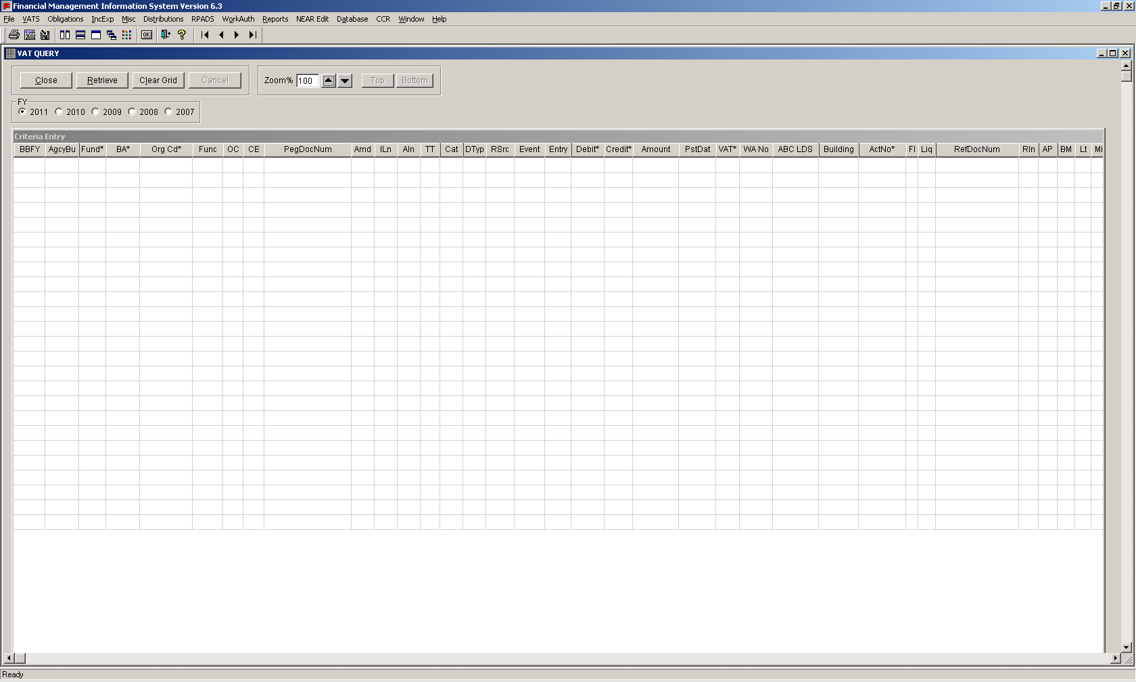
Figure 21: Pegasys VAT Query Grid Screen
Below is an example of the results of an actual Pegasys VAT Query Grid Report:

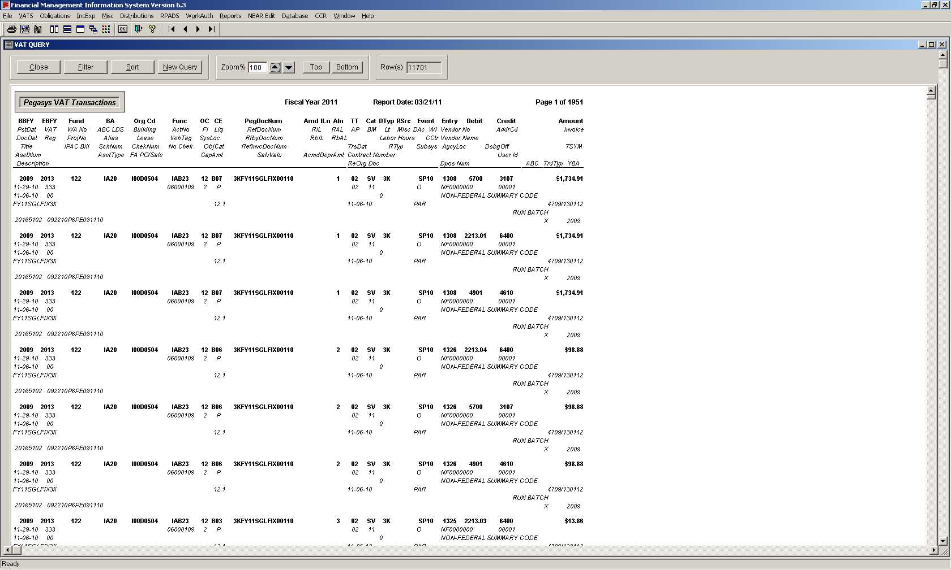
Figure 22: Pegasys VAT Query Report

VAT Search

When to Review this Section
- To extract transactions (or vat)
- To generate similar results as that of the vats query grid with filter and sort functions

Instructions to Use the VAT Search

  - At the main FMIS menu, select VATS
  - Select “VAT Search”
  - Select the VAT of preference from the drop-down menu
  - If necessary, include the beginning and ending range of VATs for search on the top part of the screen
  - Enter a value in atleast one of the fields with an aterick and choose relevant operator in front drop down menu
  - Once all criteria has been entered, select “Retrieve”
  - The User may now print, save or exit the data results as needed

Below is an example of the initial screen of an actual VAT Query:

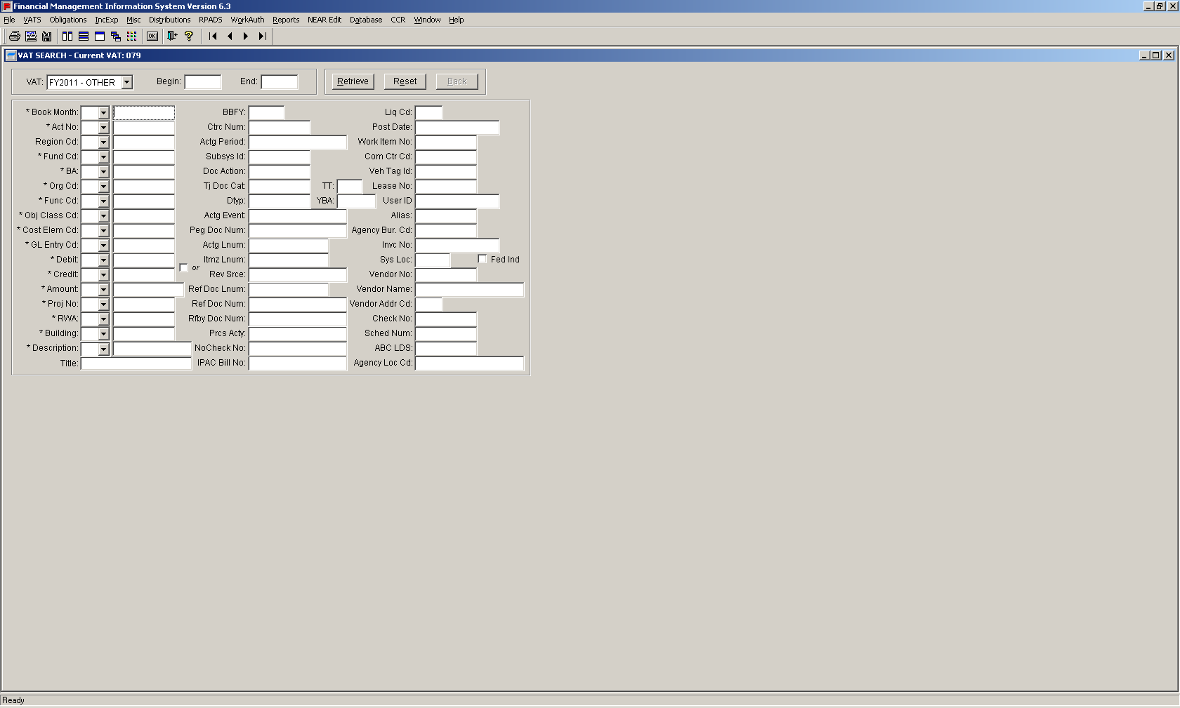
Figure 23: VAT Query Screen
Below is an example of the results of an actual VAT Query Report:

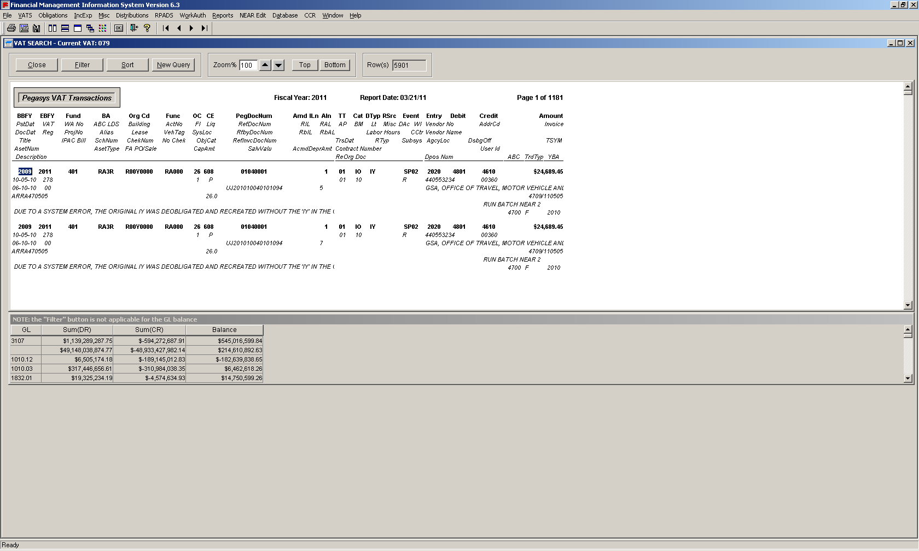
Figure 24: VAT Query Report Screen

Quick Tip #10: RUNAWAY QUERIES
Sometimes the results of a User’s query will exceed 10,000 rows. In these cases, FMIS will display an option to halt the query due to the significant delay that this may imply. The below screen is of the warning that appears to the User:
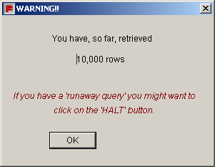
Figure 25: Runaway Query Alert
Transactions by Document Number(s)

When to Review this Section
- To obtain accounting transactions/entries for all documents that are related to the input document
- To display any related payments

Instructions to Extract Transactions by Document Number(s)

  - At the main FMIS menu, select VATS
  - Select “Transactions by Document Number(s)”
  - Select the fiscal year of preference
  - Select appropriate accounting code

PR – Purchase Request
PO – Purchase Order
AE – Estimated Accrual
RC – Receipt
PA – Payment Authorization

  - Enter referenced document number
  - Select “OK”
  - The User may now print, save or exit the data results as needed

Below is an example of the initial screen of the Transactions by Document Numbers Query:

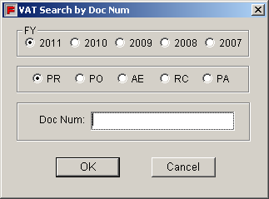
Figure 26: Transactions by Document Numbers Query Screen
Below is an example of the results of an actual Transaction by Document Numbers Query Report:

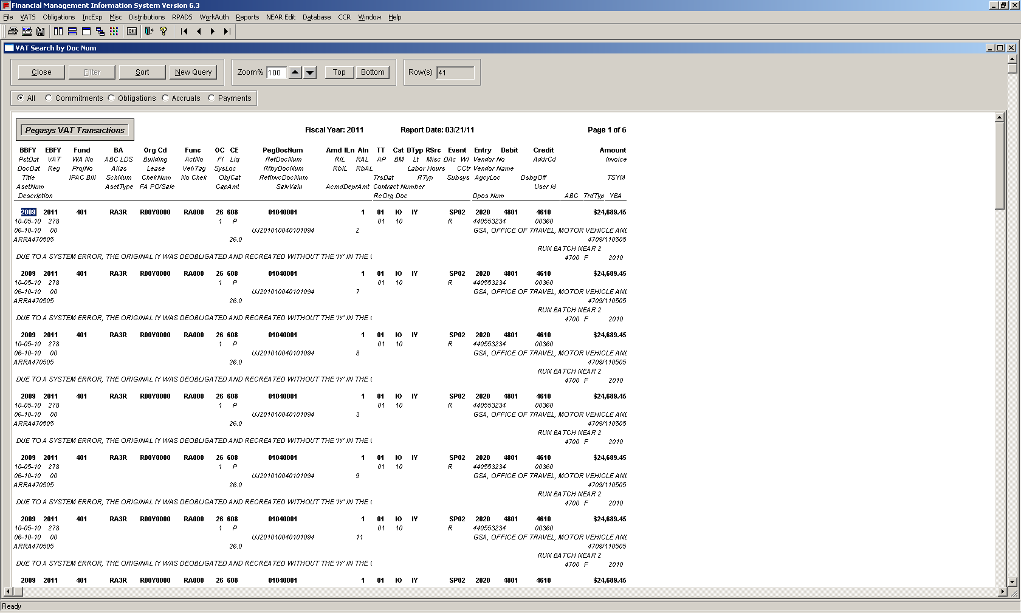
Figure 27: Transactions by Document Numbers Query Report

e. Income and Expense

When to Review this Section
- To extract income and expense information using the query grid and canned queries
- To display monthly columns and a consolidated amount at a summarized level without additional transactional detail
- To display the income and expense for any building by book month as well as by fiscal year
- To display the ga overhead expense and dcc distribution

Instructions to Extract Income and Expense Data

- At the main FMIS menu, select “IncExp”
- Select “Query Grid”
- Select the fiscal year of preference
- If necessary, choose the order of display preference for data results in the first line of the grid (i.e. ascending, descending)
- Enter search criteria starting on second line of grid
- Once all criteria has been entered, select “Retrieve”
- The User may now print, save or exit the data results as needed

Below is an example of the results of the initial screen of the Income Expense Query Grid:

Figure 28: Income Expense Query Grid

Below is an example of the results of an actual Income Expense Query Grid Report:
Figure 29: Income Expense Query Grid Report

Quick Tip #11: Selection of Specific Non-Query Grids
The Income Expense menu provides various additional options for FMIS Users to select specific non-query grids, to display Income and Expense transactions summarized by various criteria, including the following:

Fund Ba
Fund Rg Ba
Fund Rg Ba Fc
Fund Rg Ba Oc
Fund Rg Ba Oc Ca
Fund Rg Ba Org
Fund Rg Ba Org Fc Oc Ce
Fund Rg Oc Ca
Fund Rg Org Ba
Fund Rg Ba Org Oc Ce
Fund Rg Org Ba Fc Oc Ce
Travel Expense
Project IE Summary
FSS Fleet Income and Expense (Reflects historical NEAR data)
PBS Direct Expense (Reflects historical NEAR data)
PBS Building Inc and Expense (Reflects historical NEAR data)
PBS Building GA Expense (Reflects historical NEAR data)
PBS Building DCC Alloc (Reflects historical NEAR data)

Criteria Code Key: Rg = Region, Fc = Function Code, Ba = Budget Activity, Oc = Object Class, Ce = Cost Element

f. Obligations

When to Review this Section
- To extract obligation and delivered order by book month
- To display transactions in monthly columns at a summarized level

Instructions to Extract Obligations Data

- At the main FMIS menu, select “Obligations”
- Select “Query Grid”
- Select the fiscal year of preference
- If necessary, choose the order of display preference for data results in the first line of the grid (i.e. ascending, descending)
- Enter search criteria starting on second line of grid
- Once all criteria has been entered, select “Retrieve”
- The User may now print, save or exit the data results as needed

The Obligations Query Grid allows the User to enter any combination of the input criteria. All functionalities of a FMIS Query Grid are available for the Obligations Query Grid, such as Wild Cards, the save option, and the ability to retrieve additional information by double-clicking on accounting elements.

Below is an example of the initial screen of the Obligations Query Grid:
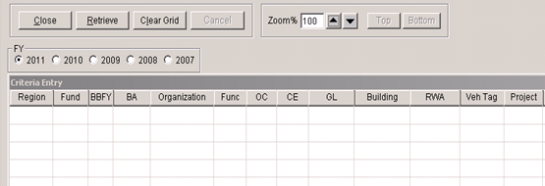Figure 30: Obligations Query Grid

Below is an example of the results of an actual Obligations Query Grid Report:

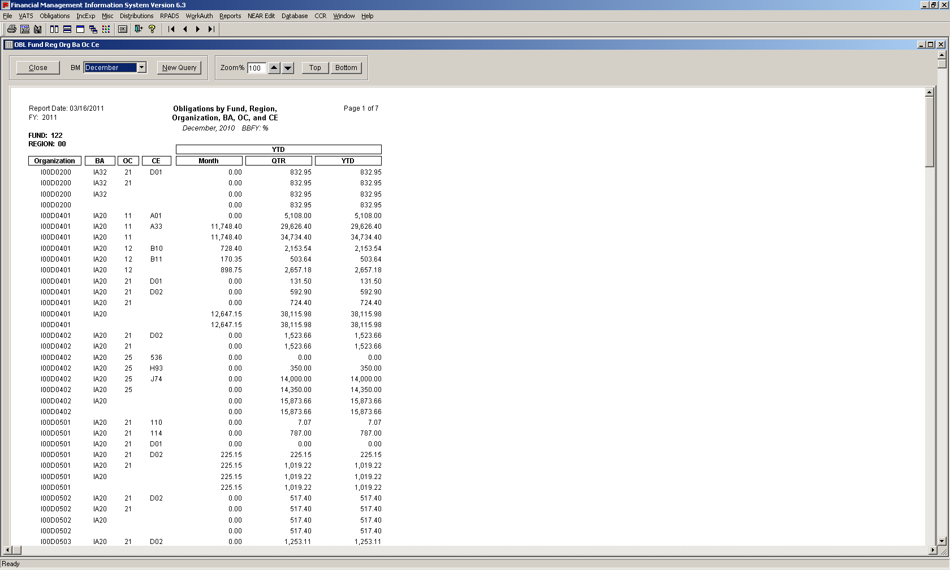
Figure 31: Obligations Query Grid Report

Quick Tip #12: Selection of Specific Non-Query Grids
The Obligations menu provides various additional options for FMIS Users to select specific non-query grids, inlcuding the following:

Limitation Travel by Account

Obligations by Ba, Nationwide
Obligations by Ba, Regional
Obl Fund Oc Ce
Obl Fund Rg Ba Org
Obl Fund Rg Ba Org Oc Ce (w/ PYRec)
Obl Fund Rg Ba Org Fc Oc Ce (w/ PYRec)
Obl Fund Rg Ba Fc (w/ PYRec)
Obl Fund Rg Org Ba Oc Ce
Obl Fund Rg Org Ba Fc Oc Ce
Obl Travel (w/ PYRec)
Project Obligation
Project Obligation Summary

Delivered Orders Fund Rg Org Ba Fc Oc

Obl Bldg Fund Ba Fc
Obl Bldg Fund Ba Oc
Obl Bldg Fund Ba Org Fc

192X Recur Reimb Obl Rg Ba Org
192X Recur Reimb Obl Rg Ba Org Ba Fc Oc
192X Recur Reimb Obl Rg Org Ba Fc Oc Bldg

Criteria Code Key: Rg = Region, Fc = Function Code, Ba = Budget Activity, Oc = Object Class, Ce = Cost Element, Obl = Obligation, Recur = Recurring, Reimb = Reimbursement, Bldg = Building, PYRec = Prior Year Recovery

g. Pegasys Open Item Summary and Detail

The Open Items Summary Query Grid

When to Review this Section
- To obtain information on obligations or open balances, the accrual/receipt open balance, and the total of all payments for a particular order or accounting line

Instructions to Use the Open Items Summary Query Grid

- At the main FMIS menu, select “Misc”
- Select “Pegasys Open Items Summary Query Grid”
- If necessary, choose the order of display preference for data results in the first line of the grid (i.e. ascending, descending)
- Enter search criteria starting on second line of grid
- Once all criteria has been entered, select “Retrieve”
- The User may now print, save or exit the data results as needed

Keep in mind that if order has been closed for 60 days, the order will have a zero balance and close, no longer including it in the results for this query.

Below is an example of the results of an actual Pegasys Open Items Summary Query Grid Report:

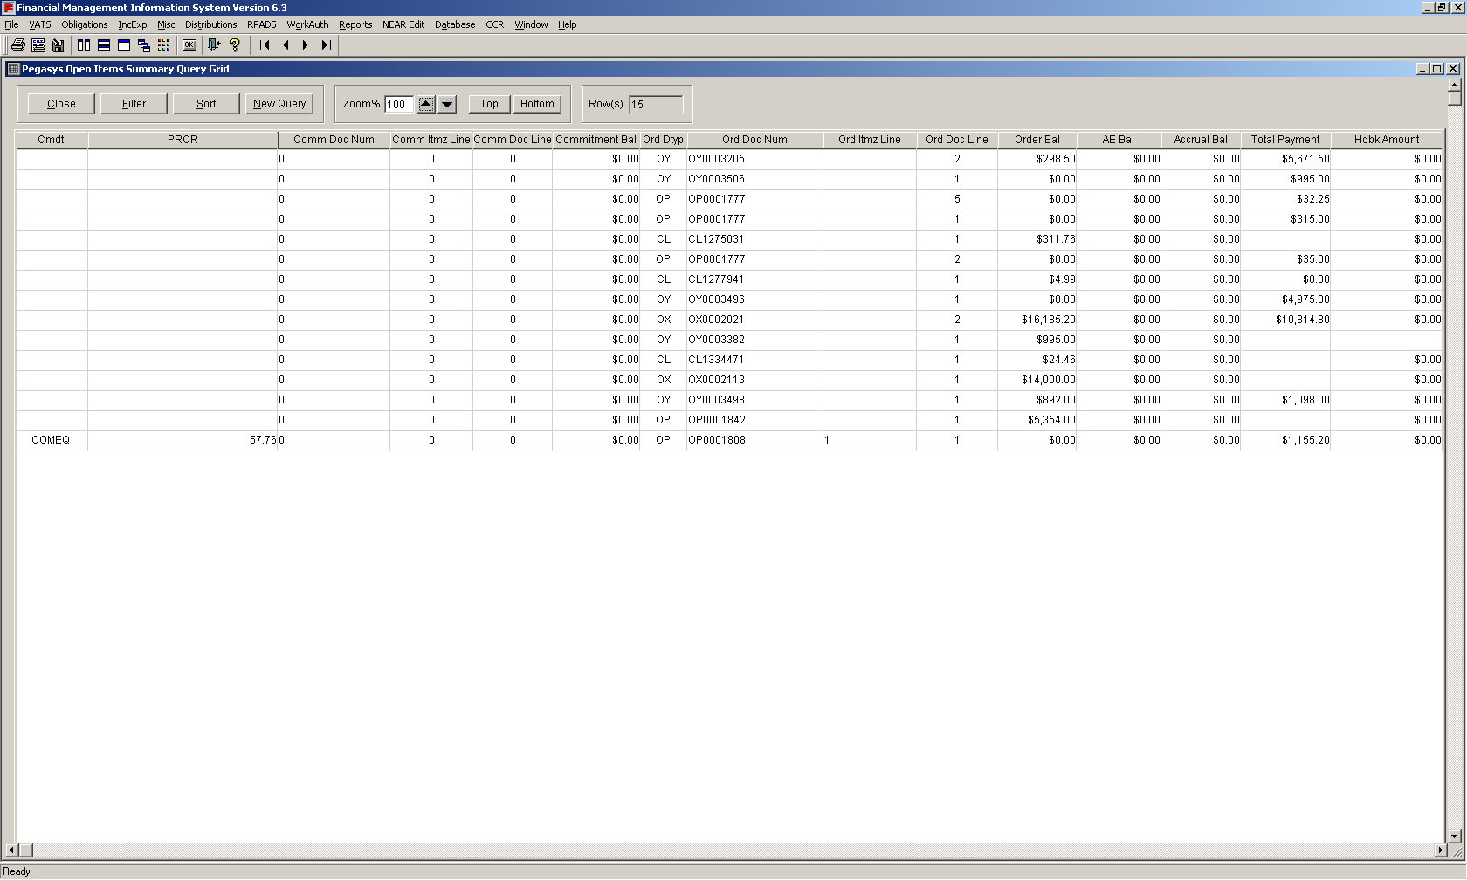
Figure 32: Pegasys Open Items Summary Query Results
The Open Items Detail Query Grid:

When to Review this Section
- To search for all documents that link to a particular request, to purchase order, receipt and payment
- To display the balance/amount of each document
- To use a payment document number to generate results for receipts, orders, and requests (when applicable).

Instructions to Use the Open Items Detail Query Grid

- At the main FMIS menu, select “Misc”
- Select “Pegasys Open Items Detail Query Grid”
- If necessary, choose the order of display preference for data results in the first line of the grid (i.e. ascending, descending)
- Enter search criteria starting on second line of grid
- Once all criteria has been entered, select “Retrieve”
- The User may now print, save or exit the data results as needed

Below is an example of the results of an actual Pegasys Open Items Detail Query Grid Report:

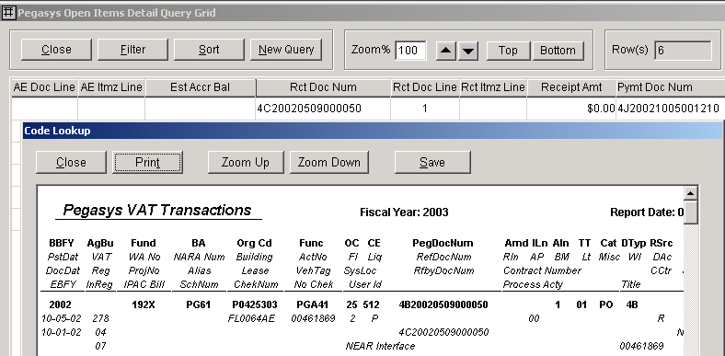
Figure 33: Pegasys Open Items Detail Query Results

h. Pegasys Trial Balance Detail and Summary

When to Review this Section
- To pegasys trial balance in summary, including prior month close, change in the current month and year to date balance
- To obtain a quick balance of a fund and standard general ledger
- To obtain a quick glance at current month change

The Trial Balance Summary Query Grid

Instructions to Use the Trial Balance Summary

- At the main FMIS menu, select “Misc”
- Select “Pegasys Trial Balance Summary Query Grid”
- Select fiscal year of preference
- If necessary, choose the order of display preference for data results in the first line of the grid (i.e. ascending, descending)
- Enter search criteria starting on second line of grid
- Once all criteria has been entered, select “Retrieve”
- The User may now print, save or exit the data results as needed

Below is an example of the results of an actual Pegasys Trial Balance Summary Query Report:

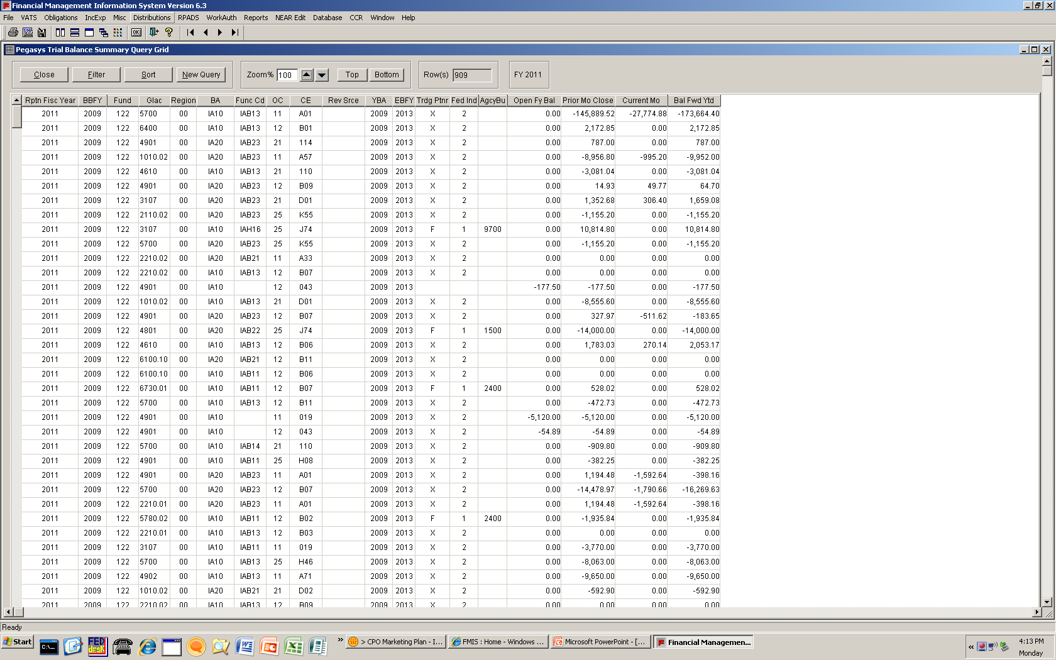
Figure 34: Pegasys Trial Balance Summary Query Results
The Trial Balance Summary Query Grid

When to Review this Section
- To view pegasys trial balance in detail, with monthly itemizations

Instructions to Use the Trial Balance Detail

- At the main FMIS menu, select “Misc”
- Select “Pegasys Trial Balance Detail Query Grid”
- Select fiscal year of preference
- If necessary, choose the order of display preference for data results in the first line of the grid (i.e. ascending, descending)
- Enter search criteria starting on second line of grid
- Once all criteria has been entered, select “Retrieve”
- The User may now print, save or exit the data results as needed

Below is an example of the results of an actual Pegasys Trial Balance Detail Query Report:

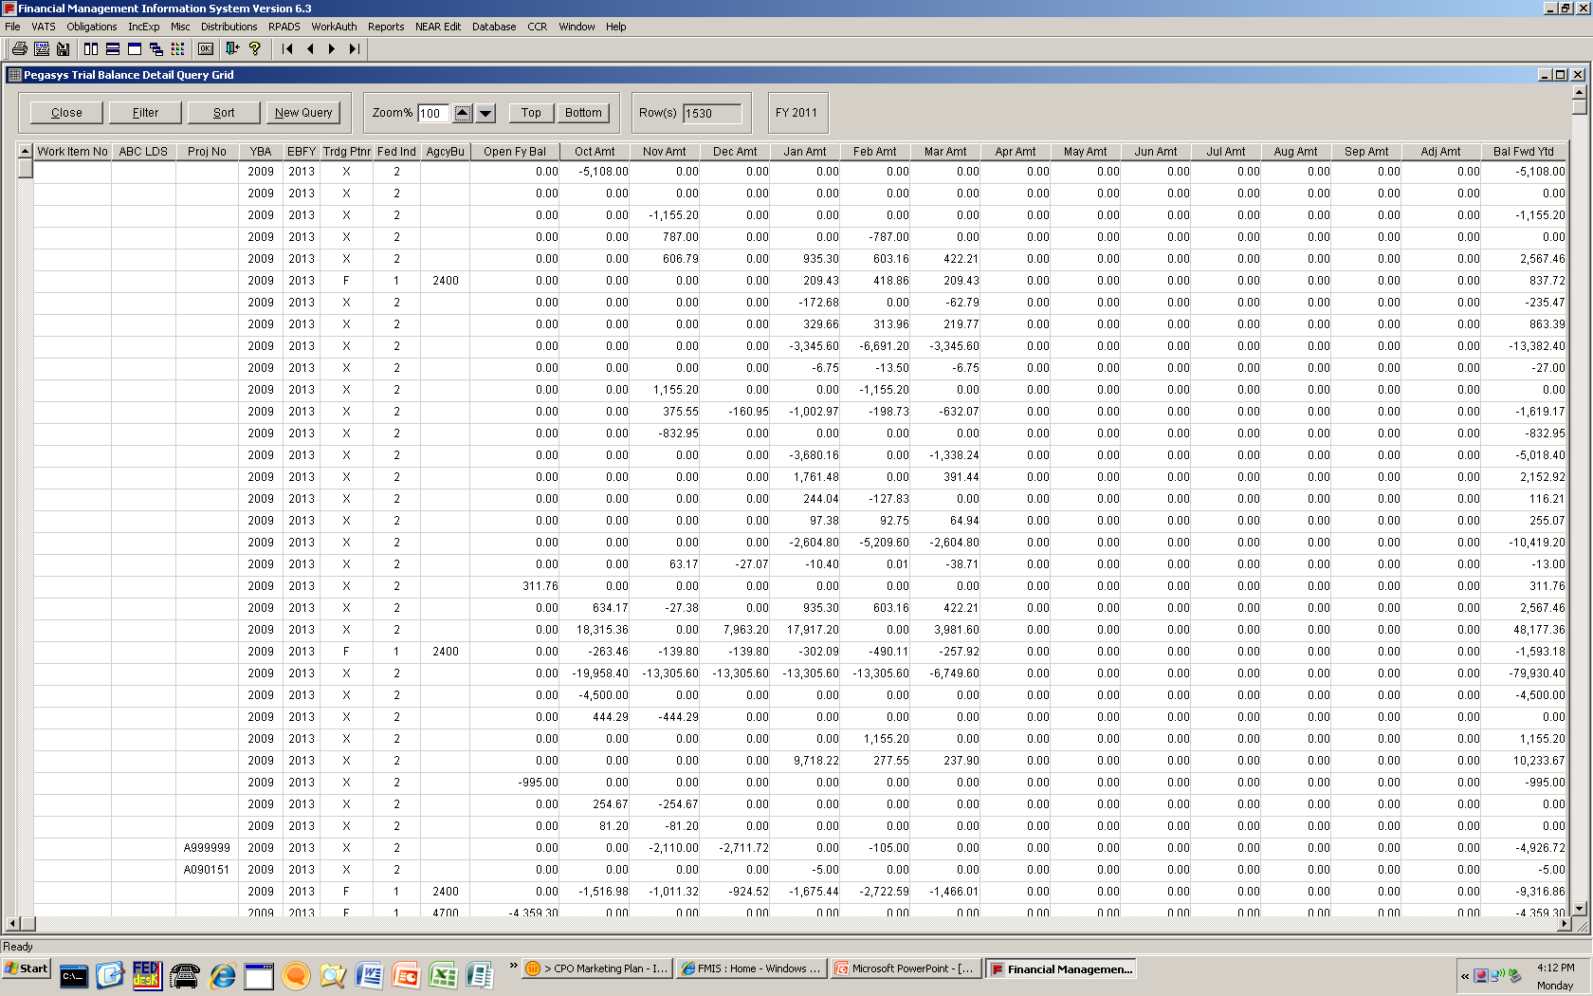
Figure 35: Pegasys Trial Balance Detail Query Results

i. Work Authorization

When to Review this Section
- To generate reports pertaining to reimbursable work authorizations (rwas)

Instructions to Use the Work Authorization Query

- At the main FMIS menu, select “WorkAuth”
- Select “Work Authorization Summary Query Grid” or ““Work Authorization Details Query Grid”
- If necessary, choose the order of display preference for data results in the first line of the grid (i.e. ascending, descending)
- Enter search criteria starting on second line of grid
- Once all criteria has been entered, select “Retrieve”
- The User may now print, save or exit the data results as needed

Below is an example of the results of an actual Work Authorization Query Report:

Users can click the ‘Show Detail’ button to see the detailed transactions that support the report.

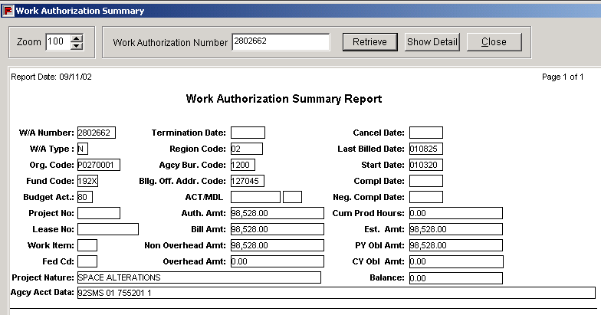
Figure 36: Work Authorization Summary Query Report
In addition to the Work Authorization Query Grid reports, the Work Authorization menu also offers various RWA Exception Reports as non-query grids.

The report options are highlighted in the table below.
Table 7: RWA Exception Reports
Exception Report | Definition
RWAs without Obligations | RWAs with no linked obligation records
RWAs with Costs/Obligations Older than One Year | RWAs with outstanding costs or obligations which are older than 365 days
RWAs with Authorized Amounts over $500,000 | RWAs with authorized amounts in excess of $500,000
RWAs with Obligations Exceeding Authorized Amount | RWA’s where obligations are greater than the authorized amount

Instructions to Use the RWA Exception Report Query

- At the main FMIS menu, select ‘WorkAuth’
- Select ‘RWA Exception Reports‘
- Click on the appropriate Exception Report
- Enter Org Code OR RWA Number OR Region (depending on which report you run). Using a wildcard, FMIS Users may enter a partial RWA Number, which will retrieve results beginning with this number
- Select “Retrieve”

j. RPADS and RPADS Capital Report

RPADS

When to Review this Section
- To add personalized query search criteria to generate rpads data

Below is an example of the initial screen of RPADS Query:
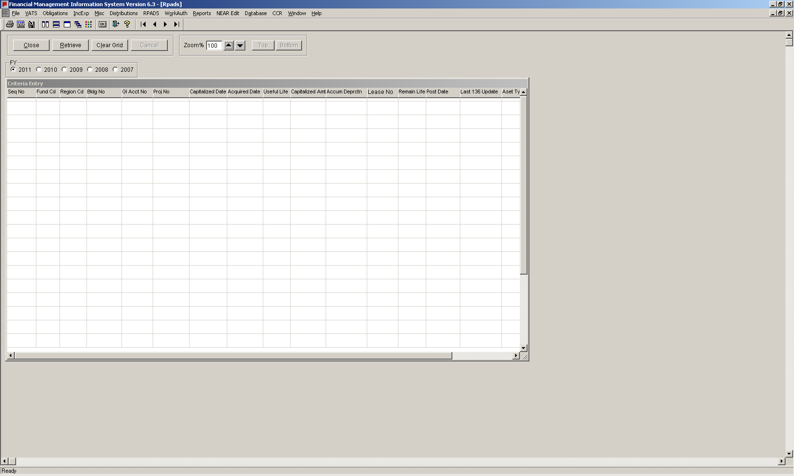
Figure 37: RPADS Query Grid Screen
Instructions to Use the RPADS Query

- At the main FMIS menu, select “RPADS”
- Select “RPADS”
- Choose fiscal year of preference
- If necessary, choose the order of display preference for data results in the first line of the grid (i.e. ascending, descending)
- Enter search criteria starting on second line of grid
- Once all criteria has been entered, select “Retrieve”
- The User may now print, save or exit the data results as needed

RPADS Capital Report

WHen to Review this Section
- To capture the capitalized value and accumulated depreciation for a specific building

Below is an example of the initial screen of RPADS Capital Report Query:

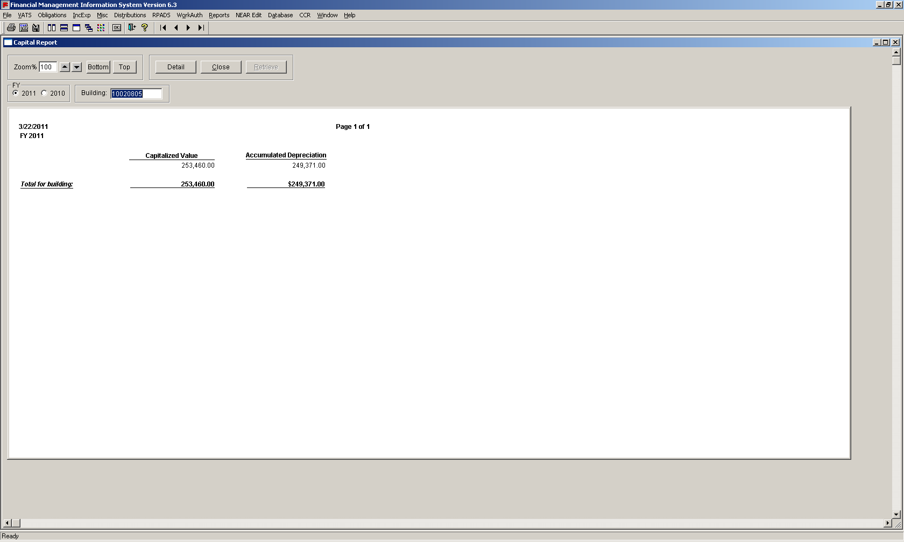
Figure 38: RPADS Capital Report

Instructions to Use the RPADS Capital Report Query

- At the main FMIS menu, select “RPADS”
- Select “RPADS Capital Report”
- Click the Detail button to view either Detail or Summary Report
- Select the fiscal year of preference
- Enter a building number
- Once all data has been entered, select “Retrieve”
- The User may now print, save or exit the data results as needed

k. Database

When to Review this Section
- To look upcleartext descriptions of various accounting dimensions found on transactions processed in Pegasys and NEAR
- .
- To determine which NEAR GLs crosswalks to specific Pegasys Standard GeneralLedger accounts

Instructions

- At the main FMIS menu, select “Database”
- Click the menu function of preference
See below for a description of what each Database function entails

Primarily designed as a reference tool for FMIS Users, the 'Database' menu item includes sections which can be used as a reference for data elements, cost centers, General Ledger accounts, and table descriptions, among other resources. The Database menu item includes the following selections:
Table 8: Database Menu Terms and Functions
Menu Term | Description
Data Elements | Listings of the data element description tables (e.g. action codes). These are the codes used in Pegasys and NEAR transactions
Cost Centers | Listings of the cost center description tables (e.g. building number)
General Leger Codes | Listings of Standard General Ledger accounts description tables
DODAAC Query Grid | Listings of addresses of GSA military customers
NABAS Address Query Grid | Listings of addresses of GSA civilian customers
Table Descriptions | A list of the tables in the FMIS database.
Load Status | When each FMIS table was last updated.
Indexes | A list of the indexes on each of the FMIS tables. Queries where the User specifies criteria for an indexed field can significantly speed up the query

l. Search by ACT Numbers

When to Review this Section
- To list all transactions for a specific act number
- To generate selections of obligation, accrual, payment or adjustment transactions

Below is an example of the results of an actual Search by ACT Numbers Query Report:

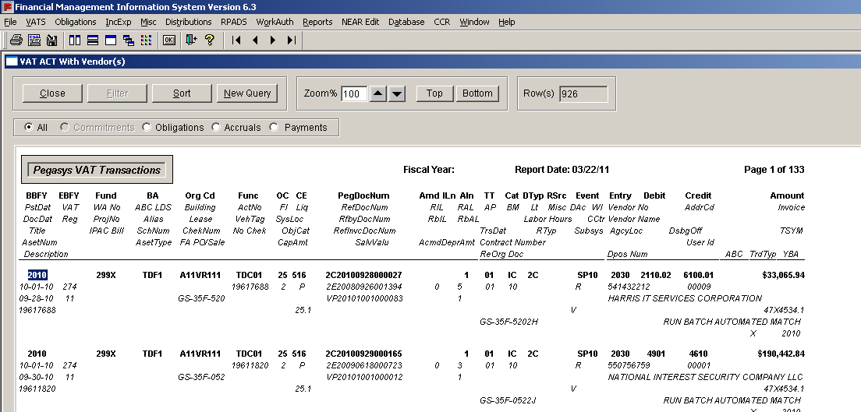
Figure 39: ACT Number with Vendor Query Report
Instructions to run an ACT Number Query

- At the main FMIS menu, select “VATS”
- Select “ACT Number”
- Choose “With Vendor, multi line” or “Without Vendor, multi line”
- Enter ACT Number
- Select fiscal year of preference
- Select “OK”
- The User may now print, save or exit the data results as needed

VII. Query Results

SECTION LEARNING OBJECTIVE
- Understand how to correctly sort and filter generated data from a query

Sorting Data

When to Review this Section
- To sort the results of a query to better review or manage the generated data

Sorting allows the User to change the order of rows of generated data in a query report. This can help prioritize or highlight more recent or delayed entries as well as valuable entries.

Instructions to Sort Data

- Click on the Sort button at the top of the query report results
- In the window that appears, click and drag the data elements you wish to base your sort on from the ‘Source Data’ space on the left to the ‘Columns’ space on the right (see the image below)
- Un-check the ‘ascending’ box if you wish to return results in descending order for that criteria
- Click the ‘OK’ button

The default sort order is by Pegasys Document Number and secondly by the accounting line number.

The number of rows will not change by sorting. When the rows are not sorted, they will be displayed in the same order in which they were entered into the database.

Multiple sorts are possible. For example, you can drag more than one data element into the Columns field. The rows of data will be sorted first by the first data element, followed by subsequent data elements.

Below is an example of the screen to specify columns to sort:

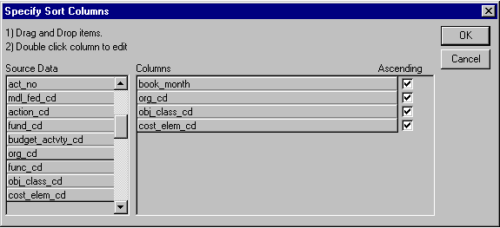
Figure 40: Sort Screen

Filtering Data

When to Review this Section
- To extract a sub-segment of data within a query report’s results
- To view only rows of data that meet defined filter parameters

Instructions to Filter Data

- Click on the Filter button
- Select the accounting dimension you wish to filter in the ‘Columns’ box, click it and paste into the empty space above
- Next, type the operator you would like to base your filter on (e.g. =, like, greater than) then add a single quotation mark (‘), the value for which you wish to filter (in the example below 25), and another single quotation mark
- Continue your filter string if required; filters can be combined. In the example, the ‘and’ operator is used to include amounts (amt) between 10-100
- Click ‘OK’
The “Verify” button will confirm the logic of the specified filter to ensure proper functioning

Below is an example of the screen to specify filters based on function and column:

Figure 41: Filter Screen
Filter expressions are case sensitive. (The rest of the FMIS application is not.) For example, use a capital P in organization.

Also, do not use quotation marks for a range of numeric values, such as when using ‘Between’ or ‘Greater than.’ For example, to filter for amounts greater than $5,000, use the following expression: amt > 5000.

VII. Saving Data

SECTION LEARNING OBJECTIVE
- Understand how to save query results to the User’s local hard drive or to the network for retrieval and use later

When to Review this Section
- Users should review this section when they wish to save their query to a local hard drive or to a mapped network drive

Instructions to Save Data
- Click File Save As or by clicking on the Save Data button
- The default file format is text with headers. Change the file type by selecting from the drop-down list labeled Save as Type to Excel with Header (do not choose Excel5). When saving data in Excel with Header, this format will retain the column heading information for the User’s spreadsheet
- Name the file, keeping the file extension the application supplied (.xls for MS Excel)
- Use the drop-down menu to select the preferred network drive or local disk which correpsonds to the User’s computer
- Click the Save button

Below is an example of the screen that Users will see upon saving a file:

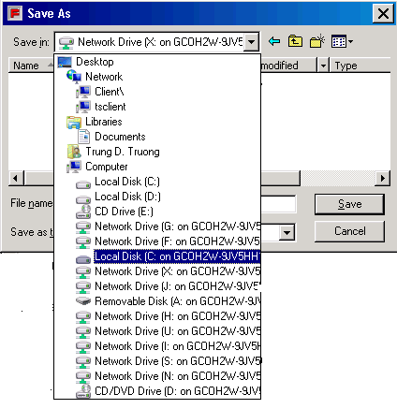
Figure 42: Save Screen

VIII. Printing Data

SECTION LEARNING OBJECTIVE
- Understand how to successfully print query results to mapped printers

When to Review this Section
- Users should review this section when they wish to print query reports to their mapped printers

Instructions to Print

- Click on the Print button or at the main menu, or click ‘File’ and choose ‘Print’
- In the subsequent screen (see figure 36 below), the User will be prompted to choose the layout as either landscape or portrait; landscape is the default and the recommended layout
- The User can choose to print a specific page range in the appropriate box (e.g. 1-9 or 10-19)
- The user enters the number of copies required
- Click ‘OK’
- In the Print SetUp, the User may choose which printer to which to print

Landscape mode is the recommended layout option for most FMIS reports.

Below is an example of the screen that Users will see to determine page layout and printing range:
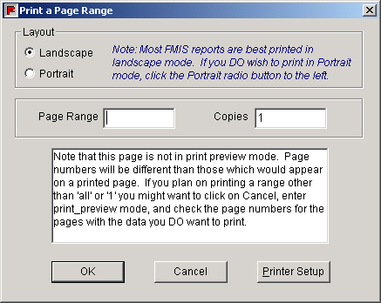
Figure 43: Print Options Screen

VIV. Trouble-Shooting Printing and Saving Issues

SECTION LEARNING OBJECTIVE
- Understand how to trouble-shoot the most common printing and saving issues

When to Review this Section
- Users should review this section when they wish to print query reports to their mapped printers or save to a location

One of the most frequently-experienced causes for User printing and saving problems is the lack of selection of full access rights within FMIS.

In order to grant full access rights from within the application, the User should perform the following steps:

- Double-click on the Citrix Program Neighborhood Connection Status icon on the lower right corner of the screen

Figure 44: CitrixProgram Neighborhood Connection Status Icon
- Within the ICA Connections window, highlight the FMIS connection and then click the “File Security” button.
Figure 45: ICA Connections Window (Citrix Version 10.2)

Figure 46: ICA Connections Window (Citrix Version 12.1)

- Within the Client File Security window, select “Full Access” and click “OK”.

Figure 47: Client File Securty Window

At this point the User should run their query again and attempt to save or print. Contact the OCFO Service Desk if issues persist.

Additionally, the User should contact the OCFO Service Desk upon receiving an error message after trying to print. This is likely due to a Citrix server error which only the OCFO Service Desk can remedy.

Below is an example of the message that Users will see due to a Citrix error:

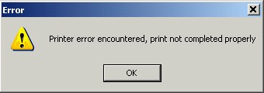
Figure 48: Printer Error

Appendix I: System Menu Functions

Listed below is a mapping of functions available under each of the drop-down menus in the main FMIS application menu:

Menu Name | Function
File | Close  Save As  Print  Print Preview  Print Setup  Change Password  Exit  Calendar  Convert .htm to .txt
VAT | Query Grid  Query Grid with VAT Range  Query Grid with Book Month  VAT Search  NEAR Detail Query Grid  ACT Number with Vendor Multiline  ACT Number without Vendor Multiline  Transactions by Document Number(s)  Category Lists  Show Last VAT Number  List of VAT numbers
Obligations | Query Grid  Limitation Travel by Account  Obligations by Ba, Nationwide  Obligations by Ba, Regional  Obl Fund Oc Ce  Obl Fund Rg Ba Org  Obl Fund Rg Ba Org Oc Ce (w/ PYRec)  Obl Fund Rg Ba Org Fc Oc Ce (w/ PYRec)  Obl Fund Rg Ba Fc (w/ PYRec)  Obl Fund Rg Org Ba Oc Ce  Obl Fund Rg Org Ba Fc Oc Ce  Obl Travel (w/ PYRec)  Project Obligation  Project Obligation Summary  Delivered Orders Fund Rg Org Ba Fc Oc  Obl Bldg Fund Ba Fc  Obl Bldg Fund Ba Oc  Obl Bldg Fund Ba Org Fc  192X Recur Reimb Obl Rg Ba Org  192X Recur Reimb Obl Rg Ba Org Ba Fc Oc  192X Recur Reimb Obl Rg Org Ba Fc Oc Bldg
IncExp | Query Grid  Fund Ba  Fund Rg Ba  Fund Rg Ba Fc  Fund Rg Ba Oc  Fund Rg Ba Oc Ca  Fund Rg Ba Org  Fund Rg Ba Org Fc Oc Ce  Fund Rg Oc Ca  Fund Rg Org Ba  Fund Rg Ba Org Oc Ce  Fund Rg Org Ba Fc Oc Ce  Travel Expense  Project IE Summary  FSS Fleet  Income  Expense  PBS  Direct Expense  Building Inc and Exp  Building GA Exp  Building DCC Alloc
Misc | Pegasys Open Items Summary Query Grid  Pegasys Open Items Detail Query Grid  Pegasys Trial Balance Detail Query Grid  Pegasys Trial Balance Summary Query Grid  Pegasys Trial Balance Summary by SGL  Pegasys Vendor Payment Search  Accounts Relationship
Distributions | PBS Dcc Allocation  PBS General Admin Overhead  PBS Labor Distribution  GSF Distribution  IT Overhead Distribution
RPADS | RPADS  RPADS Capital Report
WorkAuth | Work Authorization Summary Query Grid  Work Authorization Details Query Grid  RWA Profile Query Grid  RWA Billing Dates  Work Authorization Summary  RWA Exception Reports  RWAs Without Obligations  RWAs with Costs/Obligatiouns Older than One Year  RWAs with Authorized Amounts Over $500,000  RWAs with Obligations Exceeding Authorized Amount  M-Year RWAs  Open Items for Completed RWAs
Reports | Financial Reports On-Line  Cumulative Unapplied Collection Report
NEAR Edit | Edit Process Queries  OE Fund 255 Crosswalk  Function 455 Crosswalk  ACTG Template  General Crosswalk  Edit Error
Database | Data Elements  Accounting Event  Action Codes  Action Code Crosswalk  Agency Bureau Codes  NEAR  Pegasys  Budget Activities  NEAR  Pegasys  Commodity Code  NEAR  Pegasys  Cost Elements  NEAR  Pegasys  Fedcodes  Functions  NEAR  Pegasys  Funds  NEAR  Pegasys  Object Classes  NEAR  Pegasys  Organizations  NEAR  Pegasys  PEGASYS Document Type  PEGASYS Revenue Source  PEGASYS Transaction Definition  PEGASYS Flex Transaction Definition  Regions  NEAR  Pegasys  Subsystems  Systems  NEAR  Pegasys  Vendors  NEAR  Pegasys  Vendors, Restricted Access  NEAR  Pegasys  Cost Centers  Buildings  Building Search  Commodity Centers  Contracts  NEAR  Pegasys  Leases  Locations – 255X  Locations – 255X  455X  Plants  Products  Projects  NEAR  Pegasys  Project Line Items  Task Customer Delivery Orders  General Ledger Codes  Pegasys General Ledger  SGL-NEAR GL Crosswalk Query Grid  FTF  GSF  IT  WCF  Staff and PBS  Pegasys/ NEAR Vendor Number Crosswalk  DODAAC Query Grid  NABAS Address Query Grid  Table Descriptions  Load Status  Indexes
CCR | GSA Family Tree of DUNS Query Grid
Window | Tile  Tile Horizontal  Layer  Cascade  Arrange Icons  Toolbars
Help | Contents  Search Getting Started  User Guide  Last Query Times  Display Last SQL Statement Used in a Query  About  Problems, Information, Sugestions, Help

Appendix II: Historical Modifications to Valid Accounting Transactions

- FMIS includes access to various cost allocation queries that are no longer utilized but which provide historical data prior to FY2006.
- Previously, the following six different queries existed: Entire Distributions Menu, PBS Dcc Allocation, PBS General Admin Overhead, PBD Labor Distribution, GSF Distribution, and IT Overhead Distribution.
- There is no ACT Number generated as of October 2002. Each Pegasys spending chain may include of a Purchase Request, Purchase Order, Estimate Accrual, and Receipt. Each of these documents has different document type and different document number. For documents that were processed prior to October 1, 2002, NEAR’s ACT Number can still be used to research data. In order to research for the entire chain of the spending, the User needs to use the VAT Query for Transaction by Document Number as described earlier in this document.
- There is no Action Code for Pegasys accounting transactions to show Commitment, Obligation, Accrual, Payment or Adjustment. The User will need to use the Document Category and the Document Type to derive the phases of spending for on-line document.
  - For Commitment, the Document Category for Purchase Request is IQ for Itemized Purchase Request or TR for Training Request. The SGL for Commitment is 4700.
  - For Obligations, the Document Category is IO. The SGLs for Obligation are 4801, 4802, 4901 and 4902.
  - For Accrual, the Document Category is AE. The SGLs for Accrual are 4901 and 4902.
  - For Payment the Document Category is IP. The SGLs for payment are cash (1010.XX) and expense (61XX).
  - For interface transactions like FEDPAY, E2 Travel, and PAR, they will have document category of SV and TP, as well as different Document Types for depending on the transaction.

Appendix III: List of Key Data Codes and Descriptions

The following table provides a list of key data codes and descriptions referenced frequently in this Manual.
Data | Description
ABC LDS | The Activity Based Cost Code/Labor Distribution System
AcmdDeprAmt | Accumulated Depreciation Amount
ACT No | The Accounting Control Transaction number that was assigned/used in NEAR. In October 2002, ACT numbers will no longer be generated. The ACT Number is shown for historical purposes and is being gradually phased out.
AddrCd | The vendor address code represents the address that is tied to the particular transaction. Some vendors have more than one address.
AgcyBu | The Agency Bureau Code
AgcyLoc | Agency Location Code
Alias | The alias is a “credit card term” in Pegasys. It consists of the cardholders name and last four-positions of the cardholders’ credit card number. For security purposes, only the first eight-positions will be displayed.
ALn | The accounting line number is the accounting line number of the document processed.
Amd | The amendment number is a number assigned when an amendment is processed.
Amount | The dollar amount of the accounting transaction
AP | The accounting period is the fiscal month in which the accounting transaction was processed. This period starts with the first cycle of the month and ends with the last cycle of the month. The accounting period in Pegasys for October is 01.
AsetNum | Asset Number
AsetType | Asset Type
BA | The Agency Bureau Code
BBFY | The Beginning Budgeted Fiscal Year is part of the Fund ID, that shows what years funds are being charged
BM | The book month is the calendar month that corresponds with the accounting period. For example, the book month for accounting period 01 (October) is 10.
Building | The building number
CapAmt | Capitalized Amount
Cat | The document category is a two-position code that denotes the category of the document. For example, the document types “PP” (PBS Non-Itemized Order), “TP” (FTS Non-Itemized Order) and “FP” (FSS Non-Itemized Order) all fall under the “umbrella” of the document category IO (Non-Itemized Purchase Order).
CCtr | The commodity center code
CE | The cost element code is also referred as Sub-Object Class (SOC).
ChekNum | The check number is the number assigned by Treasury for a specific check or a trace number for EFT payments.
Credit | The credit standard general ledger of the accounting transaction
CtrcNo | The Contract Number is the contract number entered in Pegasys.
DAc | The document action code is a one-position code that shows the action against a document. (i.e. X is cancelled, C is a correction, A is amendment, O is original and R is liquidation).
Debit | The debit standard general ledger of the accounting transaction
DocDat | The date that the document was created
Dpos Num | Trace number for payment cancellation
DsbgOff | Disbursing Office
DTyp | The document type is a two-position code that distinguishes the type of document was processed. (i.e. PP is a PBS non-itemized order).
EBFY | The Ending Budgeted Fiscal Year is part of the Fund ID that shows what years funds are being charged.
Entry | Arbitrary four digit numebr assigned to a General Ledger posting model. Each GL entry code uniquely identifies one or more GL debit and credit pairs that will be posted to the journal.
Event | The accounting event is a four-position, pre-defined code, which signifies the type of financial activity to be performed by a given transaction. Accounting events also provide a basis for certain accounting-related edits to be performed on documents being processed.
FA PO/Sale | FLEET Purchase Order or Sales Number
FI | The fed/non-fed indicator.1 = Federal; 2= Non-Federal
Func | The five digit function code
Fund | The code that represents the Treasury Account Symbol
ILn | The itemized line number is the line number of the Pegasys document when an itemized commitment, an itemized order, an itemized receipt or itemized payment was prepared.
InReg | The region that input the transaction
Invoice | The invoice number
IPAC Bill | The Intragovernmental Payment and Collection Bill Number are assigned to bills processed through Treasury Government’s Online Accounting Link System.
Labor Hour | The labor hours from Labor Distribution
Lease | The lease number
Line Description | The line description is the first 40 positions found on the Header Accounting Line tab of a Pegasys document.
Liq | The liquidation code is a code that shows if the transaction is “partial” or “final”.
Lt | The line type is a two-position code that is similar to the adjustment indicator that denotes the type of transaction.
Misc | Indicates if the document is miscellaneously referenced
NoChek | Indicates that there is no Check Number and typically shows a deposit number or other number used in tracking the transaction.
ObjCat | OMB Object Class
OC | The object class generated in Pegasys
Org Cd | The organization code
PegDocNum | The Pegasys Document Number is the document number that was assigned by Pegasys when the document was processed.
Process Acty | The process activity code is used in conjunction with fiscal year, document type, and transaction type to determine the transaction definition. The transaction definition determines the accounting event and general-ledger posting model associated with a transaction.
Proj No | The project number
PstDat | The post date is the date that the transaction was processed.
RAL | Referenced Accounting Line
RbAL | Referenced by Accounting Line
RefDocNum | The referenced document number is the number of the previous document processed in this document chain. For example, if this transaction is for a receipt document, the referenced document number will be the order document number.
RefInvcDocNum | Referenced Invoice Document Number
Reg | The region of the organization code
ReOrgDoc | A Pegasys document that has the coding altered htrough the document reorganization process
RfbyDocNum | The Referenced By Document Number is the number of the next document processed in this document chain. For example, if this transaction is for a receipt document being closed by the payment, the payment document number will appear in this field.
RLn | The referenced accounting line is the accounting line of the referenced document.
RSrc | The revenue source code is a four-position code that further defines the type of revenue. For example, revenue is “direct” or “reimbursable”.
RTyp | Record Type
RWA No | The reimbursable work authorization number. This is the seven digit agreement number in Pegasys.
SalvValu | Salvage Value
SchNum | The schedule number is a control number assigned by Pegasys to the payment file sent to Treasury.
Subsys | The subsystem designator shows the name of the system that interfaces with Pegasys. (i.e. VITAP, CAPS, TAP, PAR, E2, etc.)
SysLoc | The system code for FTS or the location code for FSS
Title | For External Client transactions, this text field is used to display the client’s Purchase Order Number or other tracking number. This links the subsequent documents together in Pegasys.
TrdTyp | Trading Partner Type
TrsDat | The treasury date of the transaction
TSYM | Treasury Symbol for which the transaction applies
TT | The transaction type is a two-position code that is used in conjunction with the fiscal year, document type, and process activity to determine the transaction definition. The transaction definition determines the accounting event and general-ledger posting model associated with a transaction.
User Id | Iidentifies the User who processed the accounting transaction
User Dimension 5 | Re-purposed for the ABC Activity Code.
VAT | The valid accounting transaction (VAT) number is the number of the cycle the transaction was processed. It ties to the Julian date of the calendar.
VehTag | The vehicle tag number is the tag number of a Fleet Vehicle
Vend Name | The vendor name
Vendor No | The Pegasys vendor number
WI | The work item
YBA | Year of Budget Authority

Appendix IV: Pegasys Document Types

Doc Type | Name | Doc Category | Active
No Match Purchasing
Reservations
RS | Reservation | RS- Reservation | T
Requests
IQ | Itemized Request | IQ- Itemized Request | F
1A | EAS-Request | IQ- Itemized Request | F
4A | NEAR-Commitment | IQ- Itemized Request | F
BL | BPA with Limitations | IQ- Itemized Request | T
BP | BPA without Limitations | IQ- Itemized Request | T
ER | External Services Purchase Request | IQ- Itemized Request | T
IG | Intra-agency Purchase Request | IQ- Itemized Request | T
IM | Imprest Fund Commitment | IQ- Itemized Request | T
LO | Lease Purchase Request | IQ- Itemized Request | T
PR | Purchase Request | IQ- Itemized Request | T
RQ | PBS Recurring Contracts Request | IQ- Itemized Request | T
RR | Purchase Request - RWA | IQ- Itemized Request | T
TR | Training Request | IQ- Itemized Request | T
Orders
CI | Credit Card Itemized Log | IO – Itemized Order | F
IT | Itemized Intra-agency | IO – Itemized Order | F
PO | 3GS Credit Card Log | IO – Itemized Order | F
4B | NEAR-Obligation | IO – Itemized Order | F
BW | Borrowing Authority Order | IO – Itemized Order | T
CL | Credit Card Log | IO – Itemized Order | T
EO | External Services Obligation | IO – Itemized Order | T
HX | Non-Itemized Intra-agency - Software Capitalization | IO – Itemized Order | T
IX | Non-Itemized Intra-agency | IO – Itemized Order | T
IY | Fedstrip Obligation | IO – Itemized Order | T
IZ | Client Intra Agency Order | IO – Itemized Order | T
LT | Travel Relocation Obligation | IO – Itemized Order | T
WG | EOP GRANT PURCHASE ORDER | IO – Itemized Order | F
CT | Credit Card Training Log | IT- Itemized Training Order | T
Accruals
1E | VCPC -Estimated Accrual | AI – Itemized Estimated Accrual | T
2E | VITAP-FTS Estimated Accrual 3-way | AI – Itemized Estimated Accrual | T
AE | Estimated Accrual 3-way | AI – Itemized Estimated Accrual | T
AN | Estimated Accrual No-way | AI – Itemized Estimated Accrual | T
AR | Self-Reversing Estimated Accrual | AI – Itemized Estimated Accrual | T
AX | TEST -Self-Reversing Estimated Accrual | AI – Itemized Estimated Accrual | T
BE | Bulk Load Estimated Accrual | AI – Itemized Estimated Accrual | T
BQ | Bulk Load Estimated Accrual (self-reversing) | AI – Itemized Estimated Accrual | T
HE | TOPS - Estimated Accrual 3-way | AI – Itemized Estimated Accrual | T
LE | CSC - Estimated Accrual No-way | AI – Itemized Estimated Accrual | T
LR | Lease Suspense Accrual | AI – Itemized Estimated Accrual | T
LU | Lease Misc. Accrual | AI – Itemized Estimated Accrual | T
LY | Lease Year End Accrual | AI – Itemized Estimated Accrual | T
RA | PBS Recurring Contracts Estimated Accrual | AI – Itemized Estimated Accrual | T
UE | UPPS - Estimated Accrual No-way | AI – Itemized Estimated Accrual | T
2A | 3GS Self Reversing Expense Accrual | AI – Itemized Estimated Accrual | T
AI | Itemized Estimated Accrual | AI – Itemized Estimated Accrual | F
Receipts
4C | NEAR-Accrual | IC- Itemized Receipt | F
RD | Receipt - Borrowing Authority | IC- Itemized Receipt | T
RM | Receipt-Manual | IC- Itemized Receipt | T
Invoices
EV | External Services Travel Voucher/Invoice | IV- Itemized Vendor Invoice | T
IN | Non-Match Invoice For Invoice Returns | IV- Itemized Vendor Invoice | T
LV | Travel Relocation Voucher/Invoice | IV- Itemized Vendor Invoice | T
NA | Not Automated Match Invoice | IV- Itemized Vendor Invoice | T
One Way Match Purchasing
Invoices
FE | Invoices | II – Itemized Match Invoice | T
5I | FEDPAY - On-Line Invoice | II – Itemized Match Invoice | T
6V | TMR-VOUCHER | II – Itemized Match Invoice | T
8B | Tap On Line Refund Invoice | II – Itemized Match Invoice | T
8I | TAP On-Line Invoice | II – Itemized Match Invoice | T
9F | FLEET Interface Europe Invoice | II – Itemized Match Invoice | T
9I | FLEET Interface Domestic Invoice | II – Itemized Match Invoice | T
9M | FLEET Europe Manual Invoice | II – Itemized Match Invoice | T
9V | FLEET Interface Domestic Invoice ONLINE | II – Itemized Match Invoice | T
CD | DC COURTS DIRECT PAY INVOICE | II – Itemized Match Invoice | T
CN | DC COURTS DIRECT PAY NOT SUBJECT TO PP | II – Itemized Match Invoice | T
D6 | Direct Pay - Region 6, Under $2,500 | II – Itemized Match Invoice | T
D7 | Direct Pay - Region 7, Under $2,500 | II – Itemized Match Invoice | T
DC | Direct Pay - Region 6, Over $2,500 | II – Itemized Match Invoice | T
DF | Direct Pay Region 7, Over $2,500 | II – Itemized Match Invoice | T
DK | Finance Direct Pay - Region 6 | II – Itemized Match Invoice | T
DW | Finance Direct Pay - Region 7 | II – Itemized Match Invoice | T
DX | Finance Direct Pay - External Client | II – Itemized Match Invoice | T
E1 | Refunds - ADV From Others | II – Itemized Match Invoice | T
E2 | Prepayments/Refunds (General, Pers Prop, Real Prop) | II – Itemized Match Invoice | T
E3 | Refunds - A/R Reclass | II – Itemized Match Invoice | T
E4 | Refunds - TAP Advance | II – Itemized Match Invoice | T
E5 | Refunds - Deferred Credit General | II – Itemized Match Invoice | T
E6 | Refunds - Deferred Credit Unamort Short Term | II – Itemized Match Invoice | T
E7 | Prepayments (non 224 cash) | II – Itemized Match Invoice | T
E8 | Prepayments - Cash Link | II – Itemized Match Invoice | T
IL | Finance Direct Pay - Deposit Fund Liability Payment | II – Itemized Match Invoice | T
IR | Finance Direct Pay - Imprest Fund Replenishment | II – Itemized Match Invoice | T
IS | Finance Direct Pay - Imprest Fund Class D | II – Itemized Match Invoice | T
WC | EOP Direct Pay | II – Itemized Match Invoice | F
Order/Invoice Match Purchasing
Orders
2T | 3GS-Itemized Inter Agency Order | IO- Itemized Order | T
2X | 3GS Itemized Intra Agency Order | IO- Itemized Order | T
FZ | FSS-Itemized Interagency | IO- Itemized Order | F
GZ | GMA-Itemized Interagency | IO- Itemized Order | F
OZ | Other-Itemized Interagency | IO- Itemized Order | F
PZ | PBS-Itemized Interagency | IO- Itemized Order | F
TZ | FTS-Itemized Interagency | IO- Itemized Order | F
XZ | Client-Itemized Interagency | IO- Itemized Order | F
CY | DC COURTS Travel/Training Obligation | IO- Itemized Order | T
FX | FSS-Non-Itemized Interagency | IO- Itemized Order | T
GX | GMA Interagency | IO- Itemized Order | T
OX | Other Interagency | IO- Itemized Order | T
PX | PBS Interagency | IO- Itemized Order | T
TX | FTS Interagency | IO- Itemized Order | T
WX | EOP Interagency | IO- Itemized Order | F
XX | Client Interagency | IO- Itemized Order | T
ZX | PresTrans Interagency | IO- Itemized Order | T
FY | FSS-Prepaid Training Order | IT- Itemized Training Order | T
GY | GMA-Prepaid Training Order | IT- Itemized Training Order | T
NY | NARA-Prepaid Training Order | IT- Itemized Training Order | T
OY | Other-Prepaid Training Order | IT- Itemized Training Order | T
PY | PBS-Prepaid Training Order | IT- Itemized Training Order | T
TY | FTS-Prepaid Training Order | IT- Itemized Training Order | T
XY | Client-Prepaid Training Order | IT- Itemized Training Order | T
Invoices
IK | Itemized Match Invoice 2-Way R6 | II – Itemized Match Invoice | F
IW | Itemized Match Invoice 2-Way R7 | II – Itemized Match Invoice | F
MK | Match Invoice 2-Way R6 | II – Itemized Match Invoice | T
MT | DC COURTS 2-WAY INOICE | II – Itemized Match Invoice | T
MW | Match Invoice 2-Way R7 | II – Itemized Match Invoice | T
NK | NARA Match Invoice 2-Way R6 | II – Itemized Match Invoice | T
Three Way Match Purchasing
Orders
2I | 3GS Itemized Order | IO- Itemized Order | T
FO | FSS-Itemized Purchase Order | IO- Itemized Order | F
GO | GMA-Itemized Purchase Order | IO- Itemized Order | F
OO | Other-Itemized Purchase Order | IO- Itemized Order | F
PO | PBS-Itemized Purchase Order | IO- Itemized Order | F
TO | FTS-Itemized Purchase Order | IO- Itemized Order | F
XO | Client-Itemized Purchase Order | IO- Itemized Order | F
ZO | PresTrans-Itemized Purchase Order | IO- Itemized Order | F
1B | EAS-Order | IO- Itemized Order | T
2B | VITAP-FTS Order | IO- Itemized Order | T
CF | DC COURTS FIXED ORDER | IO- Itemized Order | T
CO | DCC Purchase Order | IO- Itemized Order | T
EG | External Services Grant Obligation | IO- Itemized Order | F
FC | PBS Funded Capital Lease | IO- Itemized Order | T
FP | FSS Purchase Order | IO- Itemized Order | T
GP | GMA Purchase Order | IO- Itemized Order | T
HB | TOPS - Order | IO- Itemized Order | T
OP | Other Purchase Order | IO- Itemized Order | T
PJ | PBS 3-way Obligation | IO- Itemized Order | T
PN | PBS Construction Obligation | IO- Itemized Order | T
PP | PBS Purchase Order | IO- Itemized Order | T
PS | PBS Supplemental Lease Agreement | IO- Itemized Order | T
PT | Presidential Transition PO | IO- Itemized Order | F
RO | PBS Recurring Contracts Order | IO- Itemized Order | T
TP | FTS Purchase Order | IO- Itemized Order | T
WP | EOP Purchase Order | IO- Itemized Order | F
XP | Client Purchase Order | IO- Itemized Order | T
ZP | PresTran Purchase Order | IO- Itemized Order | T
FW | FSS-Training Order | IT- Itemized Training Order | T
GW | GMA-Training Order | IT- Itemized Training Order | T
OW | Other-Training Order | IT- Itemized Training Order | T
PW | PBS-Training Order | IT- Itemized Training Order | T
TW | FTS-Training Order | IT- Itemized Training Order | T
XW | Client-Training Order | IT- Itemized Training Order | T
Receipts
2R | 3GS Itemized Receipt | IC-Itemized Receipt | T
IC | Itemized Receipt 6 | IC-Itemized Receipt | F
IF | Itemized Receipt 7 | IC-Itemized Receipt | F
1C | EAS-Receiving Report | IC-Itemized Receipt | T
1Z | Test EAS Receipt | IC-Itemized Receipt | F
2C | VITAP-FTS Receiving Report | IC-Itemized Receipt | T
FR | Receipt7-Funded Capital Lease | IC-Itemized Receipt | T
HC | TOPS - Receiving Report | IC-Itemized Receipt | T
RC | Receipt-Conversion/Interface Only | IC-Itemized Receipt | T
RK | Receipt6 | IC-Itemized Receipt | T
RT | PBS Recurring Contracts Blanket Receipt | IC-Itemized Receipt | T
RW | Receipt7 | IC-Itemized Receipt | T
Invoices
2M | 3GS Itemized Invoice | II – Itemized Match Invoice | T
2V | 3GS Itemized Invoice - Electronic | II – Itemized Match Invoice | T
I6 | Itemized Match Invoice 3-Way R6 | II – Itemized Match Invoice | F
I7 | Itemized Match Invoice 3-Way R7 | II – Itemized Match Invoice | F
M6 | Match Invoice 3-Way R6 | II – Itemized Match Invoice | T
M7 | Match Invoice 3-Way R7-VITAP | II – Itemized Match Invoice | T
MC | DC COURTS 3-WAY INVOICE | II – Itemized Match Invoice | T
MF | Match Invoice 3-Way R7 | II – Itemized Match Invoice | T
MJ | Mat Inv 3-Way R7 Partial | II – Itemized Match Invoice | T
MM | Mat Inv 3-Way R6 Partial | II – Itemized Match Invoice | T
NI | NARA Match Invoice 3-Way | II – Itemized Match Invoice | T
Accounts Payable
CC | Credit Card Cost Transfer | IF- Imprest Fund | F
CP | Credit Card Payment | IF- Imprest Fund | T
CZ | Test - Credit Card Payment | IF- Imprest Fund | T
I5 | Itemized Expenditure Refund | IP- Itemized Payment | F
II | Itemized Payment Authorization-Reg 6 Prompt Pay | IP- Itemized Payment | F
IJ | Itemized Payment Authorization Fedex | IP- Itemized Payment | F
IU | Itemized Payment Authorization-Reg 7 Prompt Pay | IP- Itemized Payment | F
2H | 3GS - Interfund Charges | IP- Itemized Payment | T
4D | NEAR-Payments | IP- Itemized Payment | F
4J | NEAR Interfund | IP- Itemized Payment | T
4M | NEAR-Contract Holdback | IP- Itemized Payment | F
4N | NEAR-Contract Holdback Release | IP- Itemized Payment | F
5D | FEDPAY - Payment Authorization | IP- Itemized Payment | T
5P | FEDPAY - On-Line Payment Authorization | IP- Itemized Payment | T
6D | TMR - Payment Authorization | IP- Itemized Payment | T
6N | TMR - On-Line OPAC Collection | IP- Itemized Payment | T
6P | TMR - On-Line Payment Authorization | IP- Itemized Payment | T
7D | CAPS - Payment Authorization | IP- Itemized Payment | T
8D | TAP - Payment Authorization | IP- Itemized Payment | T
8J | TAP - InterFund Charges | IP- Itemized Payment | T
8P | TAP - On-Line Payment Authorization | IP- Itemized Payment | T
8R | TAP - On-Line Refund Payment Authorization | IP- Itemized Payment | T
9D | AUTOPAY - Payment Authorization (Domestic) | IP- Itemized Payment | T
9G | AUTOPAY - Payment Authorization (Foreign) | IP- Itemized Payment | T
9P | AUTOPAY - Payment Authorization (Domestic) | IP- Itemized Payment | T
BA | Borrowing Authority Payment | IP- Itemized Payment | T
BC | Bulk Load Payment (non-referencing) DC Courts | IP- Itemized Payment | T
BD | Bulk Load Payment (referencing) | IP- Itemized Payment | T
BJ | Bulk Load Interfund Payment (referencing) | IP- Itemized Payment | T
BN | Bulk Load Interfund Payment (non-referencing) | IP- Itemized Payment | T
BZ | Bulk Load Payment (non-referencing) | IP- Itemized Payment | T
CA | DC Courts Payments STPP | IP- Itemized Payment | T
CB | DC Courts Payments NSTPP | IP- Itemized Payment | T
CK | Prepayments - Cash Link | IP- Itemized Payment | T
HR | Holdback Release | IP- Itemized Payment | T
HY | Interfund - Software Capitalization | IP- Itemized Payment | T
IE | Payment Authorization-R6 NonPrompt Pay - ClassD ImprestFund | IP- Itemized Payment | T
IH | Payment Authorization-R6 NonPrompt Pay - DepositFundLiabPymt | IP- Itemized Payment | T
IP | Payment Authorization - Imprest Fund Establishment | IP- Itemized Payment | F
KA | TEST Expenditure Refund | IP- Itemized Payment | T
KP | NEAR Reference Interfund | IP- Itemized Payment | T
LM | Lease Misc. Payment Authorization | IP- Itemized Payment | T
LP | Lease Payment Authorization | IP- Itemized Payment | T
LZ | Capital Lease & Installmt Contract Pymt Intrafund | IP- Itemized Payment | T
NU | NARA Allocate Prepayment | IP- Itemized Payment | T
OC | CONVERSION - Payments | IP- Itemized Payment | T
P1 | External Services Travel Payment | IP- Itemized Payment | T
P2 | External Services Travel Collection | IP- Itemized Payment | T
P3 | Travel Relocation | IP- Itemized Payment | T
P4 | Travel Relocation Collection | IP- Itemized Payment | T
P5 | Expenditure Refund | IP- Itemized Payment | T
P6 | Payment Authorization-Reg 6 Prompt Pay | IP- Itemized Payment | T
P7 | Payment Authorization-Reg 7 Prompt Pay | IP- Itemized Payment | T
P8 | Payment Authorization-Reg 6 NonPrompt Pay | IP- Itemized Payment | T
P9 | Payment Authorization-Reg 7 NonPrompt Pay | IP- Itemized Payment | T
PA | Payment Authorization Conversion | IP- Itemized Payment | T
PB | Prepayments/Refunds (General, Pers Prop, Real Prop) | IP- Itemized Payment | T
PD | Refund - A/R Reclass | IP- Itemized Payment | T
PE | Refund - TAP Advance | IP- Itemized Payment | T
PF | Payment Authorization Fedex | IP- Itemized Payment | T
PG | Refund - Deferred Credit General | IP- Itemized Payment | T
PI | Refund - Deferred Credit Unamort Short Term | IP- Itemized Payment | T
PL | Prepayments (non-224 cash) | IP- Itemized Payment | T
PM | Manual Payment Authorization | IP- Itemized Payment | T
PQ | Revenue Refund | IP- Itemized Payment | T
PU | Allocate Prepayment | IP- Itemized Payment | T
PV | TEST -Payment Authorization-Reg 6 Prompt Pay | IP- Itemized Payment | T
QJ | RWA - Interfund Charges | IP- Itemized Payment | T
SR | Schedules Refund | IP- Itemized Payment | T
UD | UPPS - Payment Authorization | IP- Itemized Payment | T
UJ | FEDBILL - Interfund Charges | IP- Itemized Payment | T
WD | EOP Grant Payment | IP- Itemized Payment | F
WJ | AUTOBILL - Interfund Charges | IP- Itemized Payment | T
YJ | CBG - Interfund Charges | IP- Itemized Payment | T
Automated Disbursements
N6 | Disbursement Cancellation R6 | CX – Disbursement Cancellation | T
N7 | Disbursement Cancellation R7 | CX – Disbursement Cancellation | T
NE | Disbursement Cancellation Ext Ser | CX – Disbursement Cancellation | T
Agreements
ED | External Direct Agreement | ED | T
IB | IBAA | ID | T
ID | Internal RWA | ID | T
General Ledger
BB | Beginning Balance | JV | T
CE | Closing Entry | JV | T
JV | Journal Voucher | JV | T
RE | Reinstatement Entry | JV | T
NV | Internal Voucher | NV | T
2F | Unfilled Customer orders | SV | T
2G | 3GS Billing | SV | T
2J | 3GS Interfund Adjustments | SV | T
2K | 3GS Self Reversing Income Accural | SV | T
2N | 3GS Cash Collections | SV | T
3K | PAR - Commitments/Accruals | SV | T
3L | PAR - All Other | SV | T
3M | PAR - Refunds/Advances | SV | T
3P | PAR - Disbursements | SV | T
4E | NEAR-Income | SV | F
4F | Payroll Commitment | SV | F
4G | Payroll Accrual | SV | F
4H | Payroll Payment | SV | F
4I | Labor Distribution | SV | F
4K | NEAR-Temporary Accrual | SV | F
4L | NEAR-Adjustment | SV | F
4P | NEAR-Temporary Income Accrual | SV | F
5B | FEDPAY - On-Line Cash Adjustments | SV | T
5C | FEDPAY - On-Line All Other | SV | T
5K | FEDPAY - Reversible Obligations/Accruals | SV | T
5L | FEDPAY - All Other | SV | T
5Q | FEDPAY - Claim Collection | SV | T
6K | TMR - Reversible Accrual | SV | T
6L | TMR - OPM Reconciliation | SV | T
8L | TAP - All Other | SV | T
8M | TAP Manual Interfund | SV | T
8Q | TAP - Collection | SV | T
9R | RWA-SV | SV | F
BK | Bulk Load Adjustment/Interfund | SV | T
BV | Borrowing Authority Adjustments | SV | T
C6 | NEAR Disbursement Cancellation - 6 | SV | T
C7 | NEAR Disbursement Cancellation - 7 | SV | T
CR | Central Office Misc. Adjustments | SV | T
CS | Cost Allocation Interfund Transfers | SV | T
DA | Deferred - To Clear Offsetting Titles on Reprt | SV | T
DB | Deferred - To Clear Charges w/o Orders | SV | T
DE | Delegation Accounting | SV | T
DL | FBF Rent & REIM - All other | SV | T
DQ | FBF Rent & REIM - Collections | SV | T
DT | Delegation Transfer (substitute for AT) | SV | T
EL | Mgmt Rptg - FBF | SV | T
ET | On-Line InterFund/InterRegion Cash Transfer (1010.10) | SV | T
EU | Clear Prepayment | SV | T
EX | TEST -Expense Transfer | SV | T
FL | MultiFund AR | SV | T
GA | Capitalize G&A (PBS) | SV | T
GB | Capitalize Imputed Costs | SV | T
GL | RPADS - Capitalization of Assets | SV | T
HK | TOPS reversible accruals | SV | T
HL | Tops all other adjustments | SV | T
HS | Homeland Security Transfer | SV | T
HZ | Software Capitalization SV's | SV | T
IA | External Services Investments | SV | T
JA | Adjustment (Unfunded - On-Line) | SV | T
JB | Adjustment (Funded - On-Line) | SV | T
JL | Labor Distribution | SV | T
JU | Judgement Claims | SV | T
KK | NEAR Reversable obligation and Income | SV | T
KL | NEAR All Other Adjustments | SV | T
KM | NEAR Interfund Adjustments | SV | T
KQ | NEAR Cash Collections | SV | T
LA | Travel Relocation Interfund/Employee Claim | SV | T
LC | Travel Relocation Interfund Cost Transfer | SV | T
LL | Capital Leases & Installmt Contracts SV's | SV | T
LS | Travel Relocation Billing | SV | T
ML | GSF - Cost Allocation Interfund Transfers | SV | T
MX | Cost Allocation Interfund Transfers | SV | T
NS | NARA On-Line InterFund/InterRegion Cash Transfer (1010.10) | SV | T
OL | On-Line IntraFund/IntraRegion Transfer (9999) | SV | T
OM | Manual Payroll | SV | T
PC | Payment Over Cancellation | SV | T
PH | Holdback Cancellation - Non Reimbursable | SV | T
PK | Expenditure Refund (One Way) | SV | T
QL | RWA - All Other | SV | T
QQ | RWA - Collections/Chargebacks | SV | T
RV | Prior Year Recovery Adjustments | SV | T
S1 | Standard Voucher (Open Items Report Update) | SV | T
S2 | Standard Voucher (Open Items Report Update) | SV | T
S3 | Standard Voucher (Open Items Report Update) | SV | T
SA | Conversion Spending Adjustment | SV | F
SC | Temporary Accrual/Temporary Obligation Reduction | SV | T
SL | NEAR Billing Module | SV | T
SP | Standard Voucher - Credit Card CP Correction | SV | F
SV | Standard Voucher | SV | T
TA | Travel Advance - Clearing w/o an Open Order | SV | T
UF | Unfilled Customer orders | SV | T
UL | FEDBILL - All Other | SV | T
UQ | FEDBILL - Collections | SV | T
VL | FAIM | SV | T
WK | AUTOBILL - Reversible Accrual | SV | T
WL | AUTOBILL - All Other | SV | T
WQ | AUTOBILL - OPAC Collections | SV | T
XL | TIRES | SV | T
YE | Year End Adjustment | SV | T
YK | CBG - Reversible Income Accruals | SV | T
YL | CBG - All Other | SV | T
ZL | RENT Module | SV | T

